Week 7 Mr Morris Graphics.
Year 7
Over the next few weeks we are going to look at recalling your knowledge from previous weeks to ensure you haven’t forgotten the basics.
Your first task is below.
I have been asked by a local design company to create some fun funky text for their new products. The words they would like us to create for are listed below.
You must select two of the words to create and add colour ( if you have coloured pencils ) thinking about what we did on colour association. However if you’re up for the challenge try 3.
Remember to add guidelines at the top and bottom so we have accurate text.
The words are.
Fairy
Crumble
Electric
Bubble
Goo
Buzz
Look at the examples below to help your way of thinking.
Remember you can ask for help at home if you get really stuck.
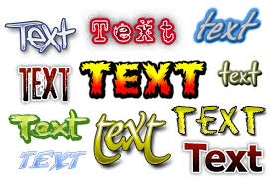
Good Luck Mr M

