READ Through the booklet and use the information provided to answer the questions

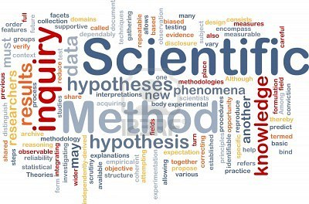

Scientific Investigation language and skills

Contents

All About Change | What are variables?  Independent, dependent and control | 4
So what’s going to happen? | Look at hypotheses and predictions | 6
Planning a practical | Look at equipment and method | 8
Is it safe? | Assessing and preventing risk during investigations | 12
What’s happening? | Looking at observations and recording results | 16
What happened? | Analyse, evaluate and conclude. It all means the same doesn’t it? | 18
Is it a good experiment? | Looking at fair testing, accuracy, anomalies and reliability | 20
Name it | Appendix of useful names of lab equipment | 22

All about Change

Often in science we are looking at “cause and effect”. You can think of the independent variable as being the “cause” and the dependent variable as being the “effect”.
In other words, the dependent variable is the thing that changes as a result of you changing something else.

The independent variable is the variable for which values are changed or selected by the investigator.

The dependent variable is the variable of which the value is measured for each and every change in the independent variable.

A control variable is one which may, in addition to the independent variable, affect the outcome of the investigation and therefore has to be kept constant or at least monitored.

Examples
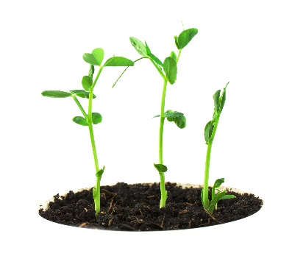
1. Dave wants to investigate how the amount of water affects the height his pea plants will grow. What are the variables involved?
- Independent: What are you changing?
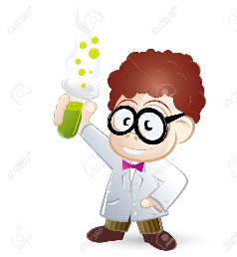
Amount of water given to pea plant

- Dependent: What are you measuring?
Height of pea plant

- Control: What things do you need to keep the same?
Type of soil, type of pea plant, amount of light, amount of soil, temperature in room etc.
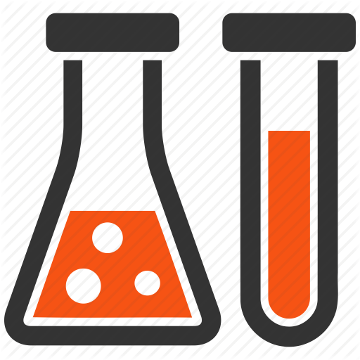
2. Alex is investigating how the temperature of Hydrochloric acid affects the rate at which marble chips will react. What are the variables involved?
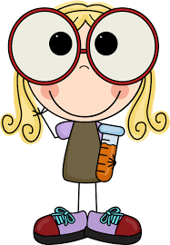
- Independent: What are you changing?
Temperature of hydrochloric acid

- Dependent: What are you measuring?
Time it takes for marble to react

- Control: What things do you need to keep the same?
Strength of the acid, amount of acid, amount of marble, surface area of marble pieces, room temperature etc.

NOW YOU TRY:
3. Katie is investigating how the height of a ramp affects the speed at which a toy car will roll down it. What are the variables involved?
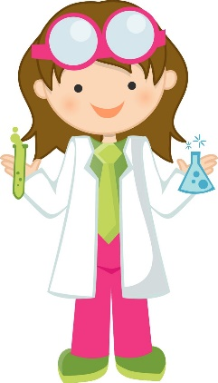
- Independent: What are you changing?
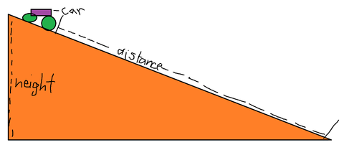

- Dependent: What are you measuring?

- Control: What things do you need to keep the same?

So what’s going to happen?
In science, it’s important to be able to state what we think is going to happen before we start, we can do this by writing a prediction.
E.g. Dave could say; “I predict that the more water I give the pea plants, the taller they will grow”

This is very basic as it doesn’t contain much scientific explanation.

Predictions not only have to state what we think will happen but also contain some scientific explanation as to why. A better example could be:

“I predict that the more water I give the pea plants, the taller they will grow. This is because plants need water to grow so won’t be able to grow very much without much water.”

OK. So now, we have a little knowledge of science but it’s still very basic and a little muddled. Better still would be to explain why plants need water.

“I predict that the more water I give the pea plants, the taller they will grow. This is because plants need water as well as light to photosynthesise and make food, the more food it is able to make, the better it will be able to grow.”

Perfect!

NOW YOU TRY:
Write a prediction for Alex and Katie’s investigations
- Alex

- Katie

Planning a practical
Ok, so we know what we’re going to investigate and what we think will happen. What now? Well, all good scientists need to be able to share their investigations with other scientists so we need to give a full set of instructions to someone else so they can do your investigation, even if you’re not there.
So what do we need?
Equipment List
The first thing you’ll need to do is list down all the equipment you’ll need in order to do your investigation. This includes anything you need to set up your practical and anything you might need to measure or control variables. It is always good to give a reason why you need things to help someone else what they are doing.
Here is Dave’s equipment list:
3 identical plant pots to grow plants in with the same amount of soil in each. (soil to be taken from the same place for each pot)
3 pea seeds to grow (from the same packet)
A measuring cylinder to measure out the water
A ruler to measure the height of the plant
A clock to measure time each day

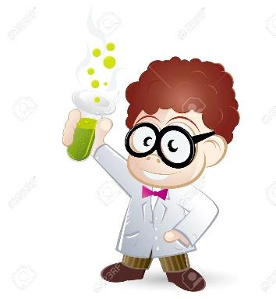

Method:
Now you’ve said what you need, you need to write instructions that are clear and logical and easy to follow. You must be careful you don’t miss any steps out or it may go wrong.
So here’s Dave’s method:
- First get three pea seeds and plant one in each pot, about 5cm below the surface.
- Place all plant pots next to each other on a windowsill indoors.
- Measure 100ml of water and give each plant 100ml of water.
- Leave for 24 hours
- Measure the height of each plant ( if visible ) from the surface of the soil to the highest point.
- Measure 100ml of water and give to plant 1
- Measure 50ml of water and give to plant 2
- DO NOT water plant 3
- Repeat steps 4-8 for 14 days

Can you follow Dave’s method?
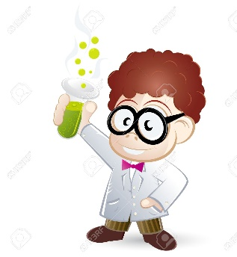
If you were given these instructions do you think you would get the same results as Dave?

NOW YOU TRY:
See if you can do the same for Alex and Katie’s investigations.

Alex:
Equipment:

Method:

Katie:
Equipment:

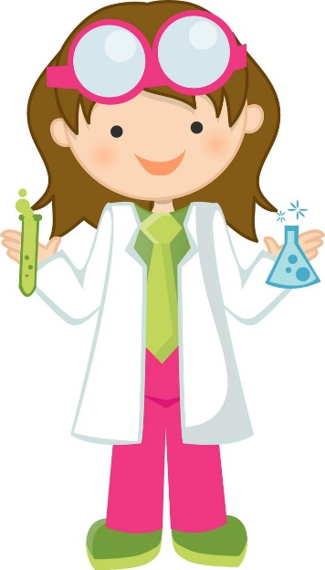

Method:

After you’ve decided what to investigate, predicted what you think will happen and planned your experiment you need to look at the risks that could be involved. This is very important in a science lab as there are often dangerous things that could hurt you.
Is it Safe?
Things to think about when deciding if an investigation is safe.
Your environment
- Is it clean and tidy?
- Are there things around you that could be dangerous for you to knock off or trip over?
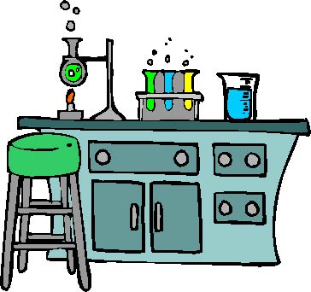
- Does it need to be light? Dark? Airey? Etc.
The space you work in is very important.

The equipment
- Do you need to use anything sharp?
- Dangerous chemicals?
- Something breakable?
- Electricity?
- Liquids that could spill and make you slip?
The things you use are essential to practical investigation so it’s important that you know how to use them safely.

Once you’ve decided what the risks are for your investigation you can start to think of things that you can do to prevent them from happening.
These could include:
- Hang bags and coats up and tuck chairs under
- Wear goggles and a labcoat
- Tie your hair up
And many more.

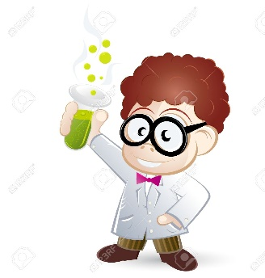
Dave’s had a look at his practical and decided what the
risks might be as well as ways he could prevent them.
This is what he came up with.

Risk: | Prevention
There is a risk that I could get germs on my hands from the soil when planting the plants. This could make me ill afterwards. | I could wear gloves and make sure I wash my hands when I’m finished. I will wash my hands every time after touching the plants.
I could get mud in my eyes if I’m not careful, especially if the mud is dusty. | I could wear goggles so I don’t get anything in my eyes.
I could trip over things on the floor. | I will hang bags on the pegs and make sure all the stools are tucked under. I will work near the windowsill and the sink so I don’t have to walk around much with equipment.
I could get mud on my clothes, this is not that dangerous but still not very nice. | I could wear an apron so I don’t get muddy.
I could spill water on the floor and slip on it. | I will be careful carrying water and if I do spill some I will clean it up straight away so I don’t slip over.

Dave’s risk assessment is a very basic one and is written from Dave’s perspective. Sometimes they can be written as instructions too. For example Dave’s first risk may be:
Risk | Precaution
Bacteria in the mud could get on your hands and make you ill. | Wear gloves and wash hands frequently.

They are both correct the first assessment is easier to write but scientists prefer the second one as usually you are writing for someone else to follow. This is a skill that you will develop over the years.

NOW YOU TRY:
Have a go at writing risk assessments for Alex and Katie’s investigations, remember to think about environment and equipment. Try one in each style.

Alex:
Risk | Precaution

Katie:
Risk | Precaution

It’s no good just setting up and running an experiment without creating any kind of record of what’s happening. There’s 2 main ways of doing this in investigations.
What’s happening?
Observations:
Make notes of what’s happening. What can you see? Write down anything you think might be important. Here are Dave’s observations
Day 1: Nothing showing on any plants yet.
Day 2: The soil in tub 3 is drying out
Day 4: Tub 1 and 2 are starting to sprout
Day 7: Tub 3 has sprouted a little
Day 11: Tub 3 has stopped growing and is very limp and yellow

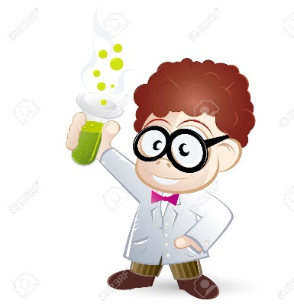

Results:
The most common way scientists record investigations is by collecting results. They can show patterns or trends and are very important in providing evidence of your investigation conclusions.
Here are Dave’s results for the first few days.
Day | Tub 1 height (mm) | Tub 2 height (mm) | Tub 3 height (mm)
1 | 0 | 0 | 0
2 | 0 | 0 | 0
3 | 0 | 0 | 0
4 | 6 | 2 | 0
5 | 11 | 5 | 0
6 | 18 | 7 | 0
7 | 23 | 11 | 2

NOW YOU TRY:
Write down some possible observations of Alex and Katie’s investigations and see if you can design a table to collect their results.
Alex:
Observations:

Results table:

Katie:
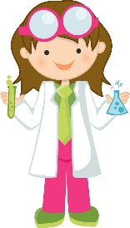
Observations:

Results table:

Once you’ve finished your investigation, collected all your results and cleaned away all the mess, hopefully without hurting yourself, you can get a pat on the back. Well done, it’s over! Well……actually……not quite. Sorry! Now we have data we need to decide what it means. What does it actually tell us about the investigation we’ve done? Well this part comes in 3 stages:
What happened?
Analysis, Evaluation and Conclusion.
Analysis is the first one we’ll tackle.
An analysis can vary in detail so we’ll start with the basics. What does your data tell you? Look at the information you wrote in the table and decide what the numbers mean. We can usually start with a basic expression that goes something like;
As we (change the independent variable) then this happened to the (dependent variable).
So David’s first analysis sentence could be;
“The more water I gave to the plants, the taller they grew.”
Alex’s could be;
“The hotter the acid was, the faster the reaction occurred”
What do you think Katie’s could be?

You could then go on to describe the patterns in your data in more detail. “As we double this….. then we double this.” If you plotted a graph from your data then you could talk about what the graph looks like and were there any anomalies in your data? We will look at anomalies in more detail later.
Analysis is quantitative: This means it uses numbers to make a point clear.

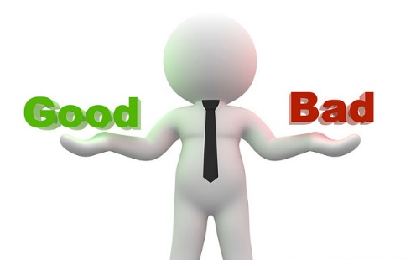
Evaluation is the next stage.
Evaluations and qualitative: this means they rely on descriptions and opinions instead of numbers.
Evaluate means to weigh up the good things and the bad things.
Some sentence starters to use for an evaluation are listed below to help you:
- My practical was good because…..
- I got the results I expected because….
- I could improve….
- If I did this practical again I would…..
- My investigation was fair because……
- My results were accurate because……….
- My results are reliable because…………
This is all about explaining the scientific process and showing you understand there could be flaws or errors in the process. It’s not about being perfect!!!

Lastly Conclusion, which tells us in summary what we found out.
This links back to your prediction and hopefully your conclusion will agree with your prediction, but don’t worry if it doesn’t. It’s more important that you understand why. Dave’s conclusion could be:
“I found out that the more water you give to a plant the taller it grows. This agrees with my prediction because plants need water to photosynthesise and grow.”

We’ve introduced three new terms in the last section which often get very confused; fair, accurate and reliable and we talked about anomalies earlier. These are all terms we use when deciding how good the data we have collected is. They are terms you need to consider when planning your experiment and also when you analyse and evaluate your investigations. So what do they all mean?
Is it a good experiment?
Fair
This is something we need to consider when planning. How will we make sure our experiment is fair? This links back to the variables we learned about at the start. In order for a test to be fair, we have to make sure that the thing we are investigating is the only thing that we are changing. We do this by stating our control variables.
For Dave’s experiment he made sure all the plants were in the same place, in the same type of soil and were buried the same distance beneath the surface. If he did not control these things then he wouldn’t know if it was the amount of water, the amount of light or minerals in the soil that affected how the plant grew, or even that it just had further to grow.

Accurate
The accuracy of the investigation is something that you need to think about during the planning, analysis and evaluation of your investigation. When we talk about accuracy in science we mean, how close the result we get is compared to its actual value. For example, the boiling point of water is 100 degrees C. However, in a lab if the whole class was to measure the temperature that each individual beaker boiled at, we may get a range of results between 95 and 105. The closer this value is to 100, the more accurate the result is.
There are many ways to improve accuracy as you experiment:
- Weighing to more decimal places e.g. 1.04g is more accurate than 1g
- Measuring in smaller units e.g. 96cm is more accurate than 1m
- Using specialised instruments to measure and weigh instead of judgment e.g. using a measuring cylinder for liquids

Reliable
Reliability is also something you need to think about in the planning and evaluation of your experiment. Your results will be reliable if other scientists repeat your experiment and get similar results. One way to make sure your results are reliable is to repeat the experiment a number of times in exactly the same way. The more times you repeat the experiment, the more raw data you will collect so you will notice any anomalies that may have occurred because of an error.

Anomalies
Anomalies are data points that have been collected that do not fit the pattern in the rest of the data. For example, let’s imagine Dave had collected the following results:
Day | Tub 1 height (mm) | Tub 2 height (mm) | Tub 3 height (mm)
1 | 0 | 0 | 0
2 | 0 | 0 | 0
3 | 0 | 0 | 0
4 | 6 | 2 | 0
5 | 11 | 5 | 0
6 | 9 | 7 | 0
7 | 23 | 11 | 2

You can see that his result for tub 1 on day 6 does not fit the pattern so we can conclude that this is an anomaly and suggest a reason why it could be wrong.
In Dave’s case, this could be simply because he may have accidentally had the ruler upside down.

Lab equipment
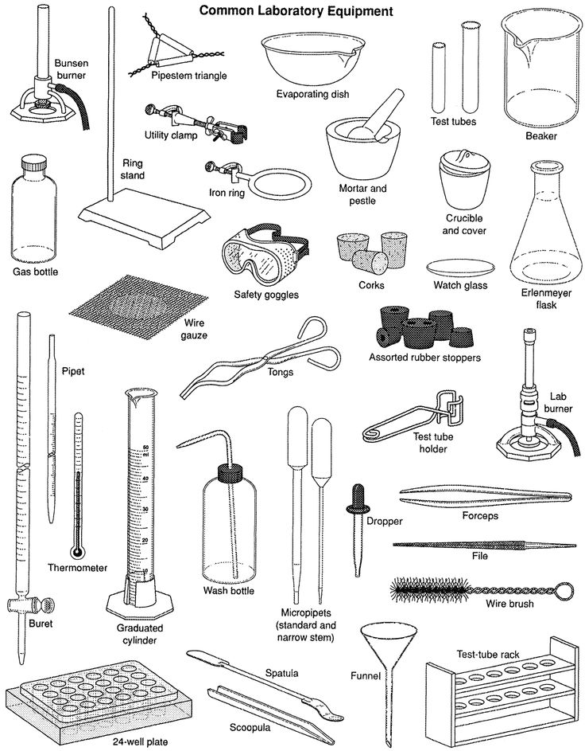

Accuracy | How close a result is to its actual, expected value | 20
Analysis | Using quantitative methods to explain results | 18
Anomaly | A result that does not fit the pattern | 21
Conclusion | A summary of the outcome of an experiment | 19
Control Variable | Variables you control to ensure a fair test | 4
Dependent variable | The variable that you measure for every value of the independent variable | 4
Equipment | The things you will need in order to complete your experiment | 8
Evaluation | An account of what went well in your practical and what you could have done better | 19
Fair | All variables remain unchanged except for the independent variable. | 20
Independent variable | The variable you change in an investigation | 4
Method | Step by step instructions for your investigation | 9
Prediction | What you think will happen backed up with scientific knowledge | 6
Qualitative | Relating to quality. Descriptions and explanations | 19
Quantitative | Relating to numbers. Results and patterns | 18
Reliability | For the data to be reliable, the variation within the values must be small. | 21
Risk | Things that could potentially harm you during the investigation | 12
Variable | That’s that could be changed in your investigation | 4
Glossary

