Spreadsheet Editing Skills
Stage 1
Skills Covered | - Entering data  - Basic formatting  - Data Types

Task 1 – Choose a Topic
- Decide what your spreadsheet is going to be about from the following options:
  - A food outlet (e.g. restaurant, fast food)
  - An activity centre (e.g. skiing, rock climbing)
  - A museum (e.g. history,

- Create a new blank Microsoft Excel spreadsheet to use for this Stage 1 worksheet

Task 2 – Entering Data/Using Cell References
- Click on cell B2 and type in Item

- Now click on cell C2 and type in Cost per Item

- Now click on cell D2 and type in Amount Sold

- Fill in the details for 5 different items in your business
You can either research these or make them up!

- Click on the line between cell C and cell D
The grey bar along the top that has all the letters

- Drag it out to the right until your text fits inside without being cut off

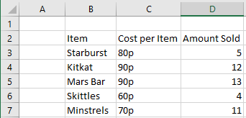
- Repeat this step to ensure none of your text is cut off

Your spreadsheet should look like this example but with different data!

Task 3 – Formatting the Table
- Make the text in cells B2 to D2 bold
This can be found under Home - Font

- Make the text in cells B3 to B7 bold
This can be found under Home - Font

- Change the background colour of cells B2 to D2
This can be found under Home - Font

- Change the background colour of cells B3 to D7 to the same colour as you did in Step 3
This can be found under Home – Font

- Highlight all the data you have typed in so far and set it to All Borders
This can be found under Home – Font

- Highlight all the data you have typed in so far again and set it to Thick Outside Borders
This can be found under Home – Font

- Highlight all the data except for the ones that are bold
Change the text justification to Centre and Middle Align
This can be found under Home - Alignment

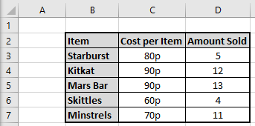
Your spreadsheet should look like this example but with different data!

Task 4 – Inserting New Sections
- Right-click on row 1 and click Insert
The grey box on the far left that has all the numbers

- Highlight cells B1 to D1 and click Merge and Centre
This can be found under Home - Alignment

- In this new, long cell type in Item Cost Table

- Use the steps from Task 3 to change this cell:
  - To have bold text
  - A background colour
  - A thick border

- Use step 1 to insert another new row at the top

- Add a 6th item to the bottom of your table

- Highlight all your data and set it to No Borders

- Use the steps from Task 3 to add the borders back in so that it includes your new item
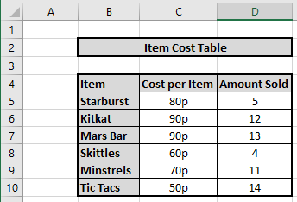
Your spreadsheet should look like this example but with different data!

Task 5 – Formatting the Data
- Click on cell B4 and look at what its current data type is set to
This can be found under Home - Number

- All the cells that contain text can stay as they are

- Highlight all the cells that contain a number (cells D5 to D10)

- Change their data type to number

- This will automatically add in some decimal places but you can get rid of them

- Click the Decrease Decimal button until they are gone
This can be found under Home – Number

- Change all your costs so that they are a number instead of a word
e.g. instead of 80p it should say 0.80

- Highlight all the cells that contain a cost (cells C5 to C10)

- Change their data type to currency
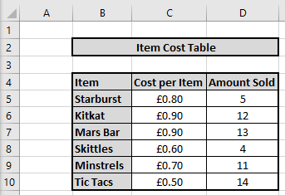
Your spreadsheet should look like this example but with different data!

Additional Challenge
Create a new Word document with the title Additional Challenge – Stage 1
Answer the questions below to show/test your understanding of the skills covered in this sheet:

- Write down the data you have stored in:
  - Cell B6
  - Cell C9
  - Cell D2
  - Cell D8

- Explain the benefit of merging cells B2 to D2 together

- Explain the benefit of changing cells B4 to D4 and cells B4 to B10 bold

- Explain the benefit of changing the background colour of cells B4 to D4 and cells B4 to B10

- Explain the benefit of changing the data type of cells C5 to C10 to currency

