Week 7 Mr Morris Graphics.
Year 8
Over the next few weeks we are going to look at recalling your knowledge from previous weeks to ensure you haven’t forgotten the basics.
Your first task is below.
Perspective drawing is a good style to use when drawing in 3D. There are different styles including single point and two point perspective. The basic example below shows how to construct a simple single point perspective drawing of a cube. Using the same skills more complex drawings/designs can be drawn, after a little practice.
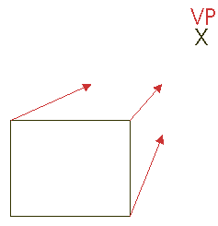 | 1. Draw one side of the cube and select a vanishing point (marked with an 'X').
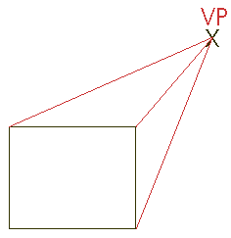 | 2. Draw very faint lines from each corner to the vanishing point.
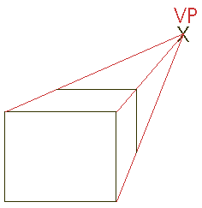 | 3. Draw horizontal and vertical lines for the 'back of the cube.
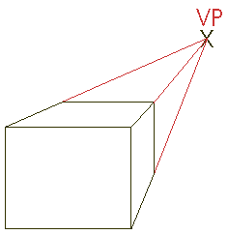 | 4. Go over the faint perspective of the cube so that the lines that make up the cube are dark and sharp

Once you have recapped this look at the you tube clip and see if you can produce the inside of the house. Don’t worry about colour a pencil drawing is fine.
REMEMBER – Don’t forget to use the parallel lines and all lines go to the VP.
https://www.youtube.com/watch?v=7ZYBWA-ifEs

If you’re up for the challenge try and add extra features.

Good Luck Mr M

