Snowfall across Britain
200 word challenge.
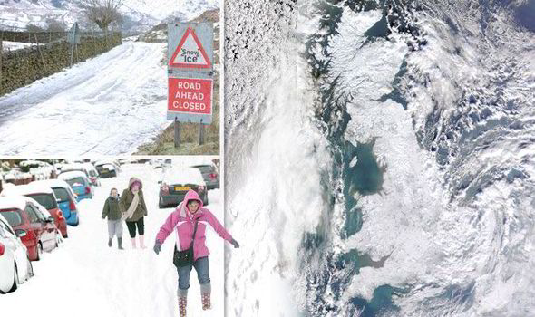

Tasks
1) Annotate the images above to identify any problems that the heavy snow has caused for the area.

2) 200 word challenge.
Produce an extended piece of writing that gives information on the following issues.

a) What has caused the heavy snow? (Try to watch the news and find out the reasons for this weather condition)
b) What problems has it created? (Try to mention the problems in our local area and across the UK as a whole. For example how is it affecting people and the environment across the country?)
c) How are people responding to the extreme weather? (Focus on what is being done to ensure people are safe and well)

