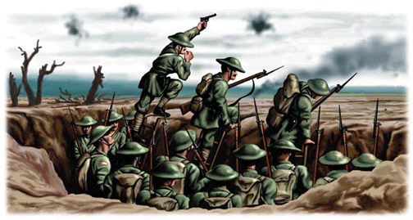**Trench conditions: What was trench warfare like?**

Name: ____________________

Class: ­­­­­­______________________

**Task 3**

Your next task is to research into conditions facing the average soldier in the trenches.

Use BBC Bitesize to help you research the following:

Conditions

_______________________________________________________________________________________________________________________________________________________________________________________________________________________________________

Disease

_______________________________________________________________________________________________________________________________________________________________________________________________________________________________________

Food

_______________________________________________________________________________________________________________________________________________________________________________________________________________________________________

Duties

_______________________________________________________________________________________________________________________________________________________________________________________________________________________________________

Fears

______________________________________________________________________________________________________________________________________________________________________________________________________________________________________

How are each of these pictures linked to trench conditions?

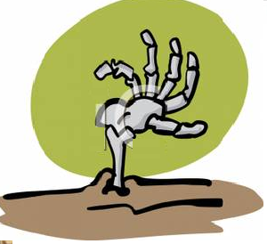

_______________________________________________________________________________________________________________________________________________________________________________________________________________________________________

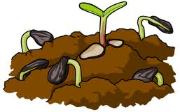

_______________________________________________________________________________________________________________________________________________________________________________________________________________________________________

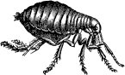

_______________________________________________________________________________________________________________________________________________________________________________________________________________________________________

http://www.clipartguide.com/_thumbs/0511-1007-1912-0861.jpg_______________________________________________________________________________________________________________________________________________________________________________________________________________________________________



**Task 4** How are the sources presenting life in the trenches?

Tell me your opinion and give examples from the sources

**Source A - Sergeant A. Vine, diary entry, 8th August, 1915**

**Source B - 'The Harvest of Battle', by CRW Nevinson in 1919**

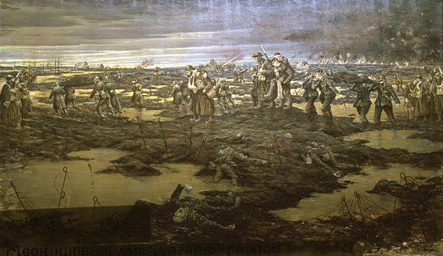

*The stench of the dead bodies now is awful as they have been exposed to the sun for several days, many have swollen and burst. The trench is full of other occupants, things with lots of legs, also swarms of rats.*

______________________________________________________________________________________________________________________________________________________________________________________________________________________________________________________________________________________________________________________________________________________________________________________________________________________________________________________________________________

_______________________________________________________________________________________________________________________________________________________________________________________________________________________________________

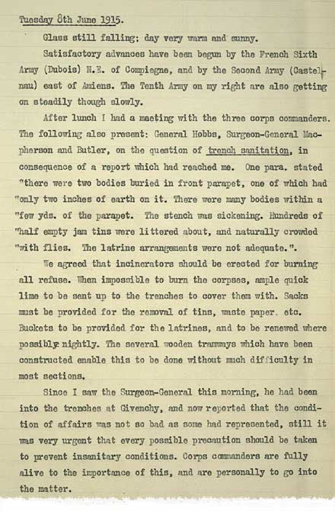

**Source C - Extract from General Haig's war diaries, June 1915**

Make a list of all the bad things Haig is mentioning in his letter.