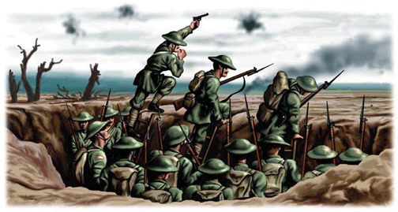**Trench conditions: What was trench warfare like?**

Name: ____________________

Class: ­­­­­­______________________

**Task 5**

Complete the definition

Censorship is…

__________________________________________________________________________________________________________________________________________________________

Censor the two letters to make sure that people back home know the soldiers are having a good time! Scribble out the negative sentences.





Why do you think the government censored letter?

______________________________________________________________________________________________________________________________________________________________________________________________________________________________________________________________________________________________________________________________________________________________________________________________________________________________________________________________________________

Write a letter home to your parents or loved one explaining the horrors of trench warfare. Make sure you include: **What were conditions like in the trenches?** **What was the morale of your fellow soldiers? How do you feel about going ‘over the top’?** **Describe in detail your emotions: fear, desperation, helplessness etc.**

______________________________________________________________________________________________________________________________________________________________________________________________________________________________________________________________________________________________________________________________________________________________________________________________________________________________________________________________________________

__________________________________________________________________________________________________________________________________________________________

_____________________________________________________________________________________________________________________________________________________________________________________________________________________________________________________________________________________________________

__________________________________________________________________________________________________________________________________________________________