Lesson 1 - Acids and Alkalis

Starter – Link the hazard symbols to the correct label and description.
Old  hazard  symbol |  | New hazard  symbol |  | Name |  | Description
1 | 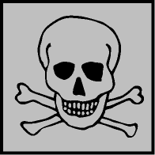 | 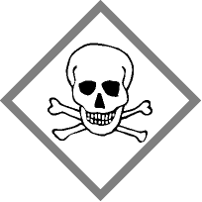 |  | Corrosive |  | This may dissolve or burn materials, including skin
2 | 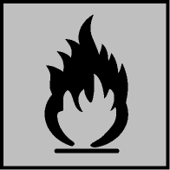 | 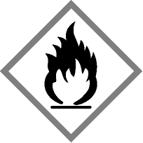 |  | Health hazard  (Harmful) |  | This includes irritants, harmful substances, and some low-hazard substances
3 |  |  |  | Explosive |  | This contains dangerous organisms such as bacteria
4 |  |  |  | Flammable |  | This can be poisonous and possibly deadly
5 | 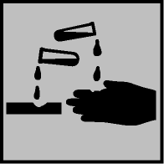 | 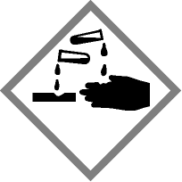 |  | Toxic |  | This may explode
6 | 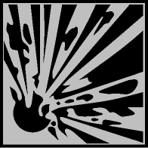 | 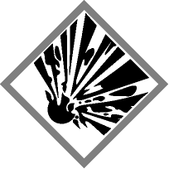 |  | Caution  (Irritant) |  | This can catch fire easily

An acid is …………………………………………………………………………………..……
………………………………………………………………………………………………………
………………………………………………………………………………………………………

An alkali is ………………………………………………………………………………….....
………………………………………………………………………………………………………
………………………………………………………………………………………………………

A concentrated solution is………………………………………………………………..
Glue along here when sticking in your book
………………………………………………………………………………………………………
………………………………………………………………………………………………………

A dilute solution is…………………………………………………………………………..
………………………………………………………………………………………………………
………………………………………………………………………………………………………

Label the concentrated and dilute solutions on the diagrams below…

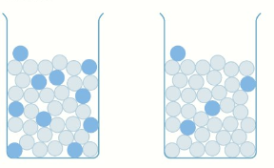
Testing for acids and alkalis
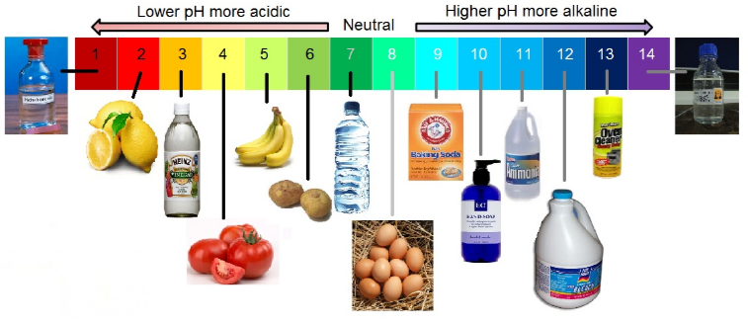
The pH scale allows us to measure how acidic or alkaline a solution is.
Acids have a pH of less than ………………………………..
Alkalis have a pH of greater than ………………………………….
A Neutral pH is . An example of this would be ………………………………………

