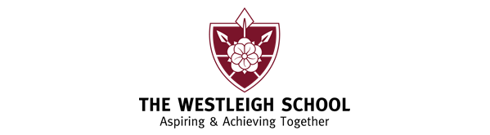
Btec Dance – Health & Safety in the Dance Studio and Technical Physical Skills in Dance
Health and safety issues
What is appropriate dress
Which styles of Dance do you like to train in and why?

Technical Physical Skills | Explanation & Example
Actions
Posture
Alignment
Balance
Coordination
Strengths
Stamina
Flexibility
Whole body participation
Movement memory

Review own practice | Explanation & Example
What does ‘review your own practice’ mean?
Identify strengths and weaknesses
Set targets

