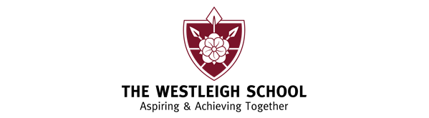

Btec Dance
Motif Development
Motif development as a choreographic device involves using a single movement or short movement phrase that is manipulated (eg, by varying the elements of movement, by repetition, by fragmentation, using different body parts) to develop movement sequences for a dance.

Motif development: is a procedure of a dance composition method that consists of transforming a basic choreographic motif to create a larger or whole piece of dance. Variations of the motif are done through strategies like repetition.

Power point – Please make notes in from the power point presentation on ‘Motif Development’.

Task – Think about a recent lesson, where you have learnt or created a short piece of dance (in any style). Think about and then ‘have a go’ at applying ‘Motif Development’, using your knowledge and understanding from the power point.

You will evaluate the process and discuss how you applied ‘Motif Development’ (during your next lesson.) Aim to use subject specific language so that you are familiarising yourself with Dance terminology.

