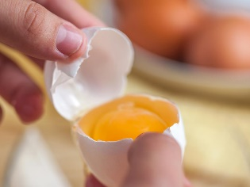
Week 7 Mr Morris Home Cooking
Year 9
Over the next few weeks we are going to look at some of the extra features we need for our course. It’s important that this work is done and can be saved and printed out when we return. Add images to work if that helps.
Your first task is below and it’s a cracking one.
1, Eggs are listed as a high risk food and can be dangerous why is this? In your own words, not copied and pasted from the internet give reasons for this, there is more than one think bacteria’s and the shell. What should we do before before we use the eggs from the box.

2 Eggs are also high risk for babies, elderly and pregnant women. Why is this? Give a detailed answer to this without copying and paste.
3 Eggs are used in cooking a great deal, but what are the two parts used for in cooking and what are they (Yellow and Clear parts). (you can use an internet diagramme to help on this one).

Remember to save this work ready to print out.

Good Luck Mr M

