GCSE Computer Science Networks Part 1

Working from home workbook

Your Name: |  | Class:

Due to school closures, self-isolations etc. it is necessary for you to stay away from school and complete work at home. We have tried to make this as easy as possible for you and have provided you with this workbook.
This workbook is designed to be used to help you continue to revise and prepare for your GCSE Computer Science exams.

Table of Contents
Networks 3
Network Hardware 4
Network Topologies 5
Recap Networks 9
Practise Exam Questions 10
Mark Your Exam Questions 11

Instructions:
Work through as many sections as you can. We understand that some of you may be ill during this time or helping to look after others who may be ill, so we ask that you do as much as you can. Obviously the more you can complete, the better you will be prepared for your exams so it is in your own interest to work through as much as you can.
Watch the videos where prompted and complete the tasks that are asked. We have tried to cut down on the printing and paper costs by only including the links to the videos and the tasks and not taken up valuable space with information you can find elsewhere. If you do not have access to YouTube please feel free to use whatever other source of information you have such as textbooks, your own notes etc. to enable you to complete the tasks.
If you have any problems with completing any of the tasks or need any extra help then please contact your teacher however please understand that if they are ill or are looking after somebody else who is ill, they will not be able to give you immediate feedback and you may have to wait for a response.
When you return to school, please bring this workbook with you so your teacher can provide feedback.
We understand this is a difficult time for many but please remain patient and contact your school or teacher if you have any questions or need any additional help.

Networks
https://youtu.be/5JMElhBJooU

If you don’t have access to YouTube, feel free to look up the information in a textbook or other source.
Now answer these questions:
- What advantage is there to a company of using a network?
- Draw a line to join the type the network to the example given.
LAN |  | Withdrawing money from a cash machine (ATM).

WAN |  | Connecting a smart watch to a person’s mobile phone so they can track the steps they take through an app on their phone.

PAN |  | A network used in a hospital which would allow doctors to read and update patients record through their laptops or tablets.

- A company usually controls their own LAN. Name two things the company may be responsible for, when maintaining that LAN?

Network Hardware
https://youtu.be/49vIf8DBQbk

If you don’t have access to YouTube, feel free to look up the information in a textbook or other source.
Now answer these questions:
- What is the Network Interface Card (NIC) used for?
- What piece of equipment joins two networks together?
❑ Switch ❑ Hub ❑ Router

- Describe the differences between a switch and a hub.
 | Switch | Hub
How do they work?
Advantage
Disadvantage

Network Topologies
For each topology, watch the video then draw an example of that topology and write an advantage and disadvantage of that topology. Ring Topology
https://youtu.be/HTMY48S5Jhc

If you don’t have access to YouTube, feel free to look up the information in a textbook or other source.
Draw an example of a ring topology:
Identify an advantage of this type of topology:
Identify a disadvantage of this type of topology:
Bus Topology
https://youtu.be/Wu2PzZGvzFY
If you don’t have access to YouTube, feel free to look up the information in a textbook or other source.
Draw an example of a bus topology:
Identify an advantage of this type of topology:
Identify a disadvantage of this type of topology:

Star Topology
https://youtu.be/Nzam8D5tPNQ
If you don’t have access to YouTube, feel free to look up the information in a textbook or other source.
Draw an example of a star topology:
Identify an advantage of this type of topology:
Identify a disadvantage of this type of topology:

Mesh Topology
https://youtu.be/oz-zDkHEVAc
If you don’t have access to YouTube, feel free to look up the information in a textbook or other source.
Draw an example of a partial mesh topology:
Identify an advantage of this type of topology:
Identify a disadvantage of this type of topology:

Recap Networks
Without looking at the previous pages, use the spaces below to write down everything you can remember about the following key phrases.
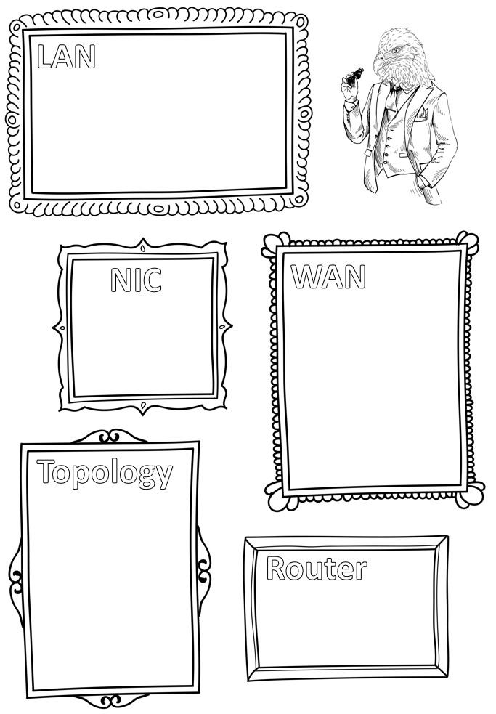

Practise Exam Questions

- State three advantages of connecting computers together with a Local Area Network. [3 marks]
...........................................................................................................................................
...........................................................................................................................................
...........................................................................................................................................
- Explain one advantage and one disadvantage of a company connecting all their computers together using a full mesh network topology rather than using a bus topology. [4 marks]
...........................................................................................................................................
...........................................................................................................................................
...........................................................................................................................................
...........................................................................................................................................
- Identify 2 pieces of hardware that are required to connect a laptop computer to a local area network and explain what they do. [4 marks]
Hardware 1: ...................................................................................................................
What does it do: ............................................................................................................
.........................................................................................................................................
.........................................................................................................................................
Hardware 2: ...................................................................................................................
What does it do: ............................................................................................................
.........................................................................................................................................
.........................................................................................................................................
- Stephen runs a small local newspaper and wants to create a star network to connect five computers together and allow everyone to share the printer. He has heard he needs either a switch or a hub. Explain to Stephen how each work so he can make an informed decision. [4 marks]
.........................................................................................................................................
.........................................................................................................................................
.........................................................................................................................................
......................................................................................................................................... .........................................................................................................................................

Page

Mark Your Exam Questions
Look back on your answers and mark them using the following criteria.
1) State three advantages of connecting computers together with a Local Area Network.
1 mark for any of the following bullet points (max 3 marks)
- Computers can share files more easily
- Computers can share hardware (peripherals) such as scanners or printers
- The computers can share an internet connection
- It is easier to install software
- Data can be backed up easily on a central server

2) Explain one advantage and one disadvantage of a company connecting all their computers together using a full mesh network topology rather than using a bus topology.
1 mark for each of the following bullet points (max 2 marks for the advantage and max 2 marks for the disadvantage)

Advantage
- If a single device fails on a full mesh network, it will not disrupt the rest of the network…
- … as the message can find another route through the network.

Disadvantage
- It is more expensive to set up…
- … as it requires more hardware (cabling).

3) Identify 2 pieces of hardware that are required to connect a laptop computer to a local area network and explain what they do.
1 mark for any of the following bullet points (max 1 mark for each type of hardware and 1 mark for the explanation of that hardware up to a max of 4 possible points)
Network Interface Card
- Allows a cable to by connected
- Created a unique IP address
Cable
- Allows data to be transmitted
Wireless transmitter
- Allows data to be transmitted over a wireless network

4) Stephen runs a small local newspaper and wants to create a star network to connect five computers together and allow everyone to share the printer. He has heard he needs either a switch or a hub. Explain to Stephen how each work so he can make an informed decision.
1 mark for any of the following bullet points (max 4 marks)
- A switch is more secure as it only transmits data to a single identified computer…
- … but can be more expensive
- A hub sends the data to all devices on the system…
- … but this increases network traffic.

Page

