GCSE Computer Science Networks Part 2

Working from home workbook

Your Name: |  | Class:

Due to school closures it is necessary for you to stay away from school and complete work at home. We have tried to make this as easy as possible for you and have provided you with this workbook.
This workbook is designed to be used to help you continue to revise and prepare for your GCSE Computer Science exams.
You can either complete this workbook electronically or you can print it out and fill it in manually.

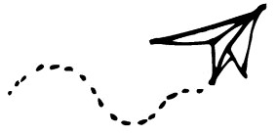

Table of Contents
Wireless and Wired Networks 3
What is the internet? 3
Wi-Fi Frequency and Channels 5
TCP/IP 4-layer model 5
Recap Networks 7
Practise Exam Questions 7
Mark Your Exam Questions 9

Instructions:
Work through as many sections as you can. We understand that some of you may be ill during this time or helping to look after others who may be ill, so we ask that you do as much as you can and please inform your teacher as soon as possible of any reason why you will not be able to complete the work.
Watch the videos where prompted and complete the tasks that are asked in the space provided. For some tasks you may need to use other software to create a drawing and we ask that you use whatever software you feel is most suitable and save these in a separate document. If you are unable to complete this workbook electronically then please contact your teacher who will help you decide what the best course of action is. If you do not have access to YouTube please feel free to use whatever other source of information you have such as textbooks, your own notes etc. to enable you to complete the tasks.
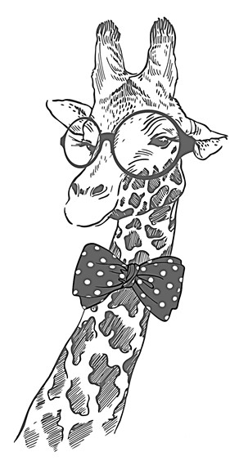
If you have any problems with completing any of the tasks or need any extra help then please contact your teacher however please understand that if they are ill or are looking after somebody else who is ill, they will not be able to give you immediate feedback and you may have to wait for a response.
We understand this is a difficult time for many but please remain patient and contact your school or teacher if you have any questions or need any additional help.

Wireless and Wired Networks
https://youtu.be/WlqzZzPrR6Q

If you don’t have access to YouTube, feel free to look up the information in a textbook or other source.
Now answer these questions:
- What are the two main brands that are used with wireless networks (WLAN)?

- How many devices can you have connected using Bluetooth network?
  - 5  6  7  8

- What area can be covered using a Bluetooth network?
  - 10 meters  20 meters  50 meters  150 meters

- Identify two advantages of using a Wi-Fi network over a Bluetooth network)?

- Why do people used caballed LANs?

- How is data sent along a copper cable?
  - Photons (light)  Electrical Pulses

- How is data sent along a fibre optic cable?
  - Photons (light)  Electrical Pulses

What is the internet?
https://youtu.be/FZPqiO5XyUs

If you don’t have access to YouTube, feel free to look up the information in a textbook or other source.
Now answer these questions:
- Briefly explain how the internet started.

- What does DNS stand for?

- How does a DNS help you find information on the internet?

- Why may it be necessary for a small organisation to pay a company to host their website?

- Describe what happens when you store your images on “the cloud”.

Wi-Fi Frequency and Channels
https://youtu.be/XIOJca1P2no

If you don’t have access to YouTube, feel free to look up the information in a textbook or other source.
Now answer these questions:
- Tick the two frequencies that are commonly used in the UK for wireless networks.
❑ 2 GHz  2.4 GHz  5 GHz  5.8 GHz

- Which frequency allows messages to travel through walls more easily?

Here is a copy of the chart that shows how the wi-fi channel overlap.
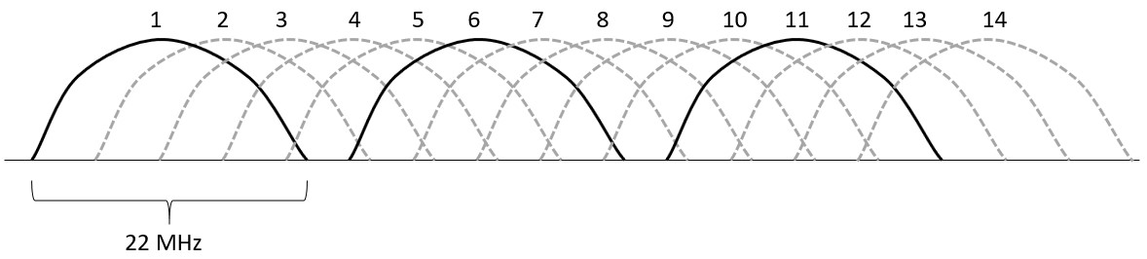
- Below you will see a row of houses showing their reach of their Wi-Fi network and the channel they are currently using. Place a tick below the two houses that will have a slower internet connection because their channels are overlapping.
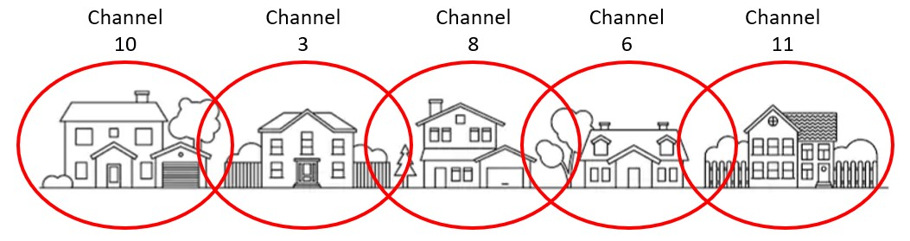
❑    

TCP/IP 4-layer model
https://youtu.be/zDY1KdnXi44

If you don’t have access to YouTube, feel free to look up the information in a textbook or other source.

Now answer these questions:
- Fill in the names of each layer in the TCP/IP 4-layer model diagram below. The top layer has been done for you:
Application

- Identify the other layer(s) the Transport layer can communicate with.

- Complete this table:
Protocol | Layer it is in | What does it do
FTP
HTTP
IMAP
IP
NIC
OS
POP
SMTP
TCP

Recap Networks
You need to create a mind map of important points you have learnt about:
- Wired and wireless networks
- What is the internet
- Wi-Fi Frequency and Channels
- TCP/IP 4-layer model
You can use whatever software you wish, such as PowerPoint. Include as much colour, images and important information as you can. Once you have created your mind map, save it and send it to your teacher along with this completed workbook. If you prefer and if you have the option of scanning in the page, then use the space below to draw your mind map and then scan it in and send it as an image to your teacher.

Practise Exam Questions
- Explain why you need an IP address to connect to the internet. [2 marks]
- State the purpose of each layer of the TCP/IP 4-layer model. [4 marks] Application:
Transport:
Internet:
Link:
- A wedding photographer currently stores all his photographs on his local hard drive and then burns a CD with the photographs which he can send to clients. Describe 3 advantages for storing his photographs in the cloud. [6 marks]

Mark Your Exam Questions
Look back on your answers and mark them using the following criteria.
1) Explain why you need an IP address to connect to the internet.
1 mark for any of the following bullet points (max 2 marks)
- IP addresses identify the device connected to the internet
- Routers use the IP addresses to direct data to the correct destination.
2) State the purpose of each layer of the TCP/IP 4-layer model.
1 mark for each of the following bullet points (max 4 marks)

Application
• Sets out the rules for how web browsers, email and file transfer systems will work

Transport
• Set rules for how devices are going to communicate together (i.e. size of packets, language used etc.)

Internet
• Splits data into packets and addresses each packet and find rout to destination

Link
• Sets out rules for how the network interface card (NIC) and operating system works
3) A wedding photographer currently stores all his photographs on his local hard drive and then burns a CD with the photographs which he can send to clients. Describe 3 advantages for storing his photographs in the cloud.
1 mark for any of the following bullet points (max 1 mark for identifying the advantages and then 1 point for explain how this is a benefit to the photographer, max 6 points in total)
- Larger capacity…
- … the cloud storage can be expanded to meet his needs • Can be accessed anywhere
- … he can access and edit his photographs whilst away from his computer.
- Send to clients…
- … can give clients access to the files without having to post them a CD that may get lost or damaged
- Can be read without CD player…
- … clients that do not own a CD reader can still access the files that are stored on the cloud

