Lesson 5 – Visualisations Learning Mat
Create your own design for the trainers below
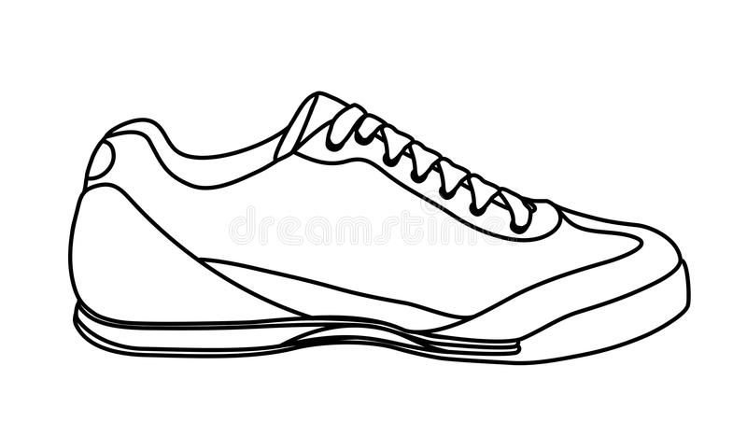

What is a visualisation? Who is the audience for a visualisation?

What type of product do we have to create a visualisation for?

What should you include in a visualisation?

Visualisation for a home page

