Name

Group

AO4
Know how food can cause ill health
LEVEL 1 / 2 AWARD IN
HOSPITALITY AND CATERING unit 1

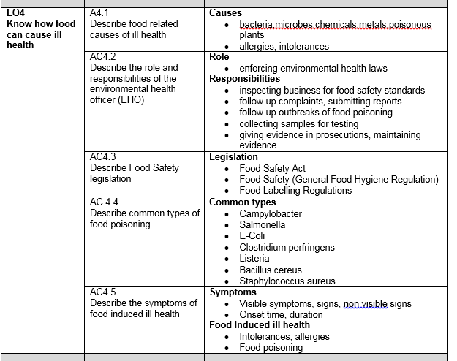

AC 4.1 Food related causes of ill health

Sources of food poisoning bacteria
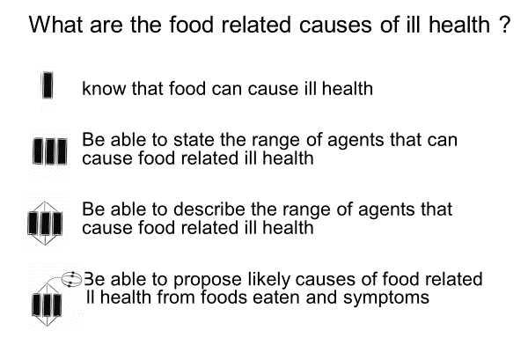

Temp | Effect on bacteria

List the symptoms of food poisoning below
1
2
3
4
5

Non bacterial causes of food related ill health

Chemicals in food that cause illness

Metals in food that cause illness
Poisonous plants

Where am I now?

Allergies and intolerances to food

Intolerance |  | Lactose (dairy products) | Coeliac (gluten products) | Yeast
Symptoms
Found in which ingredients
Foods to avoid
Alternatives you can use

A food allergy is a particular type of food intolerance that involves the body’s immune system. Food intolerances may cause uncomfortable symptoms, but only true allergies involve the immune system
- Symptoms of allergies include
- .
- .
- .
- .
- .
- .
- .
- ANAPHYLAXIS is a severe allergic reaction where the person may have tingling lips and tongue, swelling in the throat and difficulty breathing….people die from this.
- Most common foods causing anaphylaxis are……………………..
………………., ……………………., ……………….
The most common allergens in food are
……………………………………… ………………………………………..
……………………………………… ………………………………………..
……………………………………… ………………………………………..
……………………………………… ………………………………………..
……………………………………… ………………………………………..

What are the allergenic ingredients in the following?
Special fried rice
Chicken korma
Lasagne
Paella
Pizza

Why do food establishments need to provide allergy information on their menus?
…………………………………………………………………………………………………
…………………………………………………………………………………………………
…………………………………………………………………………………………………

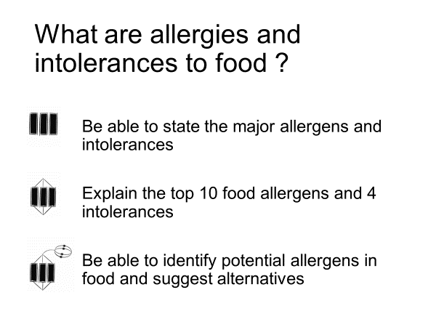

Where am I now?

AC 4.2 Environmental Health Officer- roles and responsibilities

Responsibilities of Environmental Health Officers

Role of EHOs in the Hospitality and Catering industry.
Legislation enforced by EHOs
The Food Safety Act ………………………………………………………………………………………………………………………………………………………………………………………………………………………………………………………………………………………………………………………………………………………………………………………………………………………………………………………………………………………………………………………………..

The General food hygiene Regulations ………………………………………………………………………………………………………………………………………………………………………………………………………………………………………………………………………………………………………………………………………………………………………………………………………………………………………………………………………………………………………………………………..

The Temperature control Regulations ………………………………………………………………………………………………………………………………………………………………………………………………………………………………………………………………………………………………………………………………………………………………………………………………………………………………………………………………………………………………………………………………..

The food composition Regulations ………………………………………………………………………………………………………………………………………………………………………………………………………………………………

3 main areas inspected by EHOs

EHOs have the following powers:
1…………………………………………………………………………………
2…………………………………………………………………………………..
3…………………………………………………………………………………
4…………………………………………………………………………………..
5………………………………………………………………….………………
6…………………………………………………………………………………

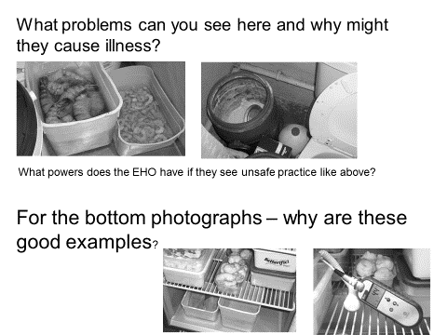
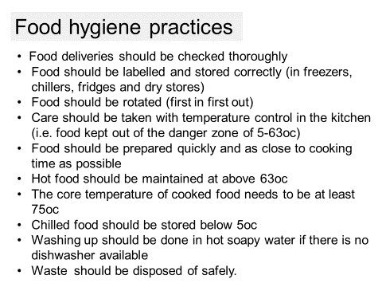
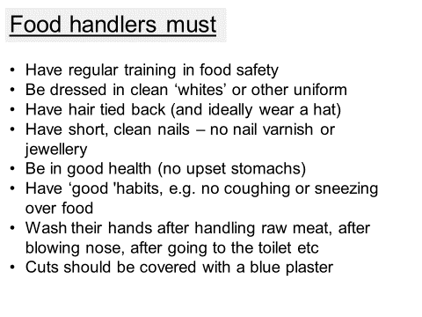
Answers to questions on slide ……………………………………………………………………………………………………………………………………………………………………………………………………………………………………………………………………………………………………………………………………………………………………………………………………………………………………………………………………………………………………………………………………………………………………………………………………………………………………………………………………………………………………………………………………………………………………………………………………………………………………………………………………………….
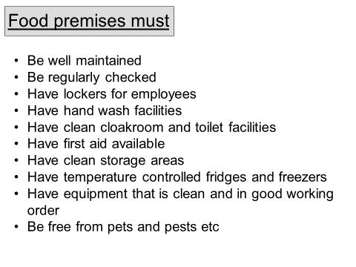

Explain how an EHO would investigate an outbreak of food poisoning (6 marks)
What are the consequences of poor inspection results?
………………………………………………………………………………………………………………………………………………………………………………………………………………………………………………………………………………………………………………………………………………………………………………………………………………………………………………………………………………………………………………………………………………………………………………………………………………………………………………………………………………………………………………………………………………………………………………………………

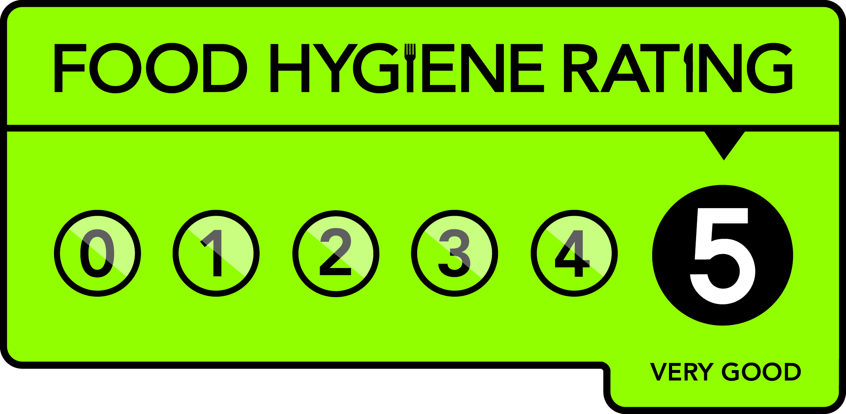
Explain the use of the Food Hygiene rating scheme
………………………………………………………………………………………………………………………………………………………………………………………………………………………………………………………………………………………………………………………………………………………………………………………………………………………………………………………………………………………………

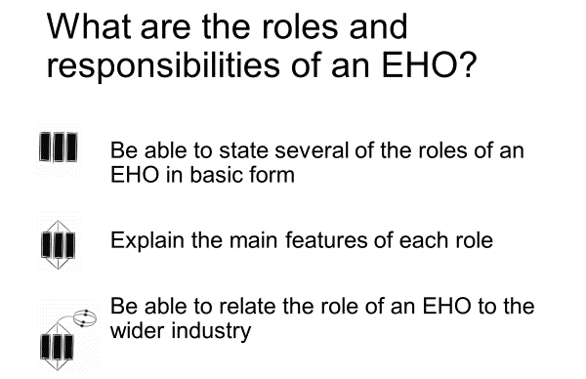

Where am I now?

At the start of this section I am at…
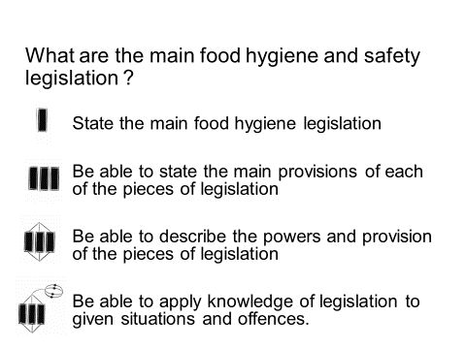

The Food safety Act 1990

Food businesses must:

Main provisions of the Food Safety Act 1990 ……………………………………………………………………………………………………………………………………………………………………………………………………………………………………………………………………………………………………………………………………………………………………………………………………………………………………………………………………………………………………………………………………………………………………………………………………………………………………………………………………………………………………………………………………………………………………………………………………………………………………………………………………..
What does the defence of Due Dilligence mean?

What would the caterer have to provide to prove they were exercising due dilligence

 | Magistrates court | Crown court
Selling food that does not comply with the Food Safety Act

Obstructing an Environmental health Officer

Other serious offences

Food Safety (General food hygiene) regulations 1995

Main provisions of the Food Safety regulations 1995 ……………………………………………………………………………………………………………………………………………………………………………………………………………………………………………………………………………………………………………………………………………………………………………………………………………………………………………………………………………………………………………………………………………………………………………………………………………………………………………………………………………………………………………………………………………………………………………………………………………………………………………………………………..

Food premises
.
.
.
.
.
.
.
.

Food Handler requirements

.
.
.
.
.
.
.

Food safety training

.
.
.
.
.

HACCP

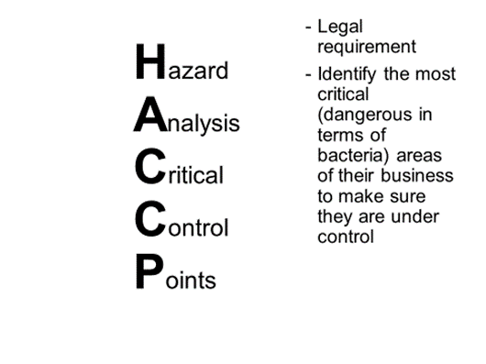

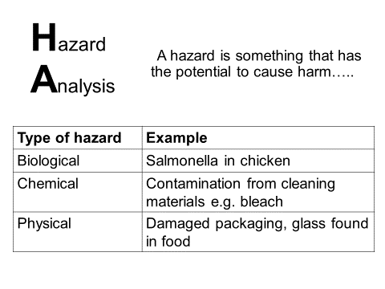
Setting up HACCP system

Using HACCP
Fill in the chart, stating what the hazards/ dangers might be at every stage and what action you would take to ensure your customers do not suffer from food poisoning

Stage | Hazard | Action
Buying
Delivery
Storage
Preparation
Cooking
Chilling

High risk foods
Cold foods- store below
Hot foods – store above
Cold foods max of at room temperature then discard or refrigerate
Hot food max of at room temperature
Buffet food max of at room temperature

Information that must appear on food labels
Name of the food
Weight or volume
Ingredient list
Allergen information
Genetically modified ingredients
Date mark and storage condition s
Preparation instruction
Name and address of manufacturer
Place of origin
Lot or batch mark
Nutrition information
The Food labelling regulations 2006

At the end of this section I am at

Campylobacter jejuni
Foods it is found in
Symptoms
Onset
Duration
Effects on body
Special points
Salmonella
Foods it is found in
Symptoms
Onset
Duration
Effects on body
Special points
Escherichia coli 0157
Foods it is found in
Symptoms
Onset
Duration
Effects on body
Special points

Clostridium perfringens
Foods it is found in
Symptoms
Onset
Duration
Effects on body
Special points
Listeria monocytogenes
Foods it is found in
Symptoms
Onset
Duration
Effects on body
Special points
Bacillus cereus
Foods it is found in
Symptoms
Onset
Duration
Effects on body
Special points
Staphylococcus aureus
Foods it is found in
Symptoms
Onset
Duration
Effects on body
Special points

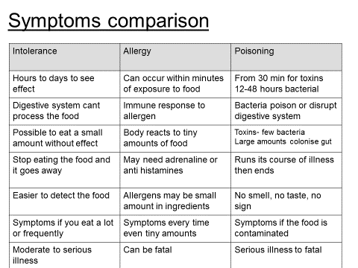

Food intolerance symptoms ………………………………………………………………………………………………………………………………………………………………………………………………………………………………………………………………………………………………………………………………………………………………………………………………………………………………………………………………………………………………………………………………………………………………………………………………………………………………………………………………………………………………………………………………………………………………………

Food allergy symptoms ………………………………………………………………………………………………………………………………………………………………………………………………………………………………………………………………………………………………………………………………………………………………………………………………………………………………………………………………………………………………………………………………………………………………………………………………………………………………………………………………………………………………………………………………………………………………………

Food poisoning symptoms ………………………………………………………………………………………………………………………………………………………………………………………………………………………………………………………………………………………………………………………………………………………………………………………………………………………………………………………………………………………………………………………………………………………………………………………………………………………………………………………………………………………………………………………………………………………………………

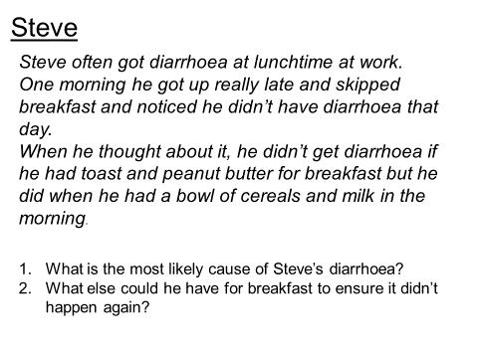
..................................................................................................................................................................................................................................................................................................................................................................

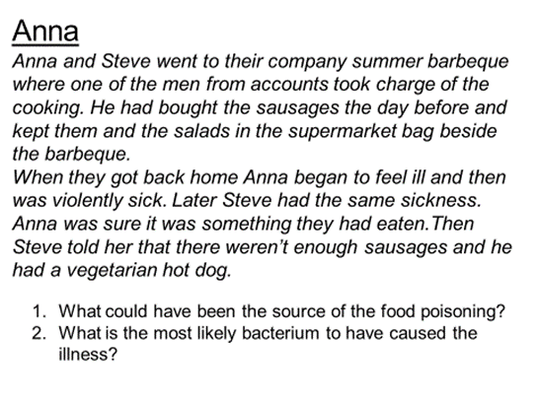
..................................................................................................................................................................................................................................................................................................................................................................

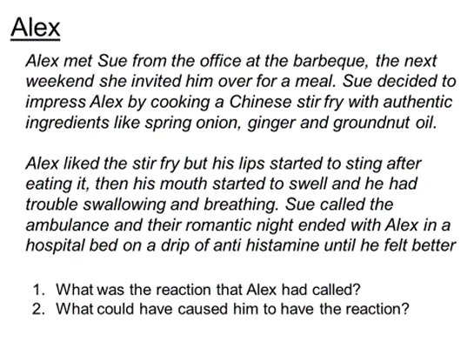
..................................................................................................................................................................................................................................................................................................................................................................

..................................................................................................................................................................................................................................................................................................................................................................

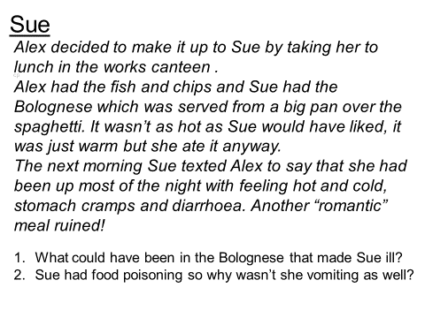

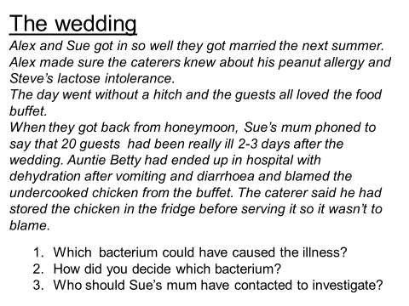
..................................................................................................................................................................................................................................................................................................................................................................

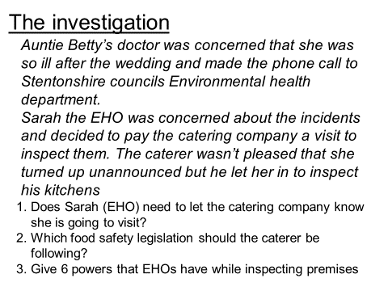
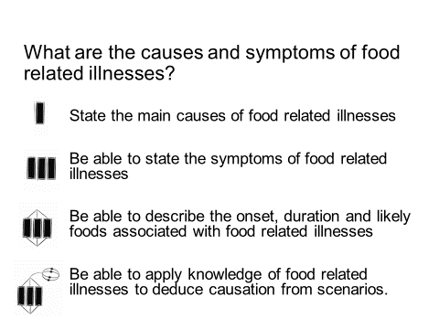
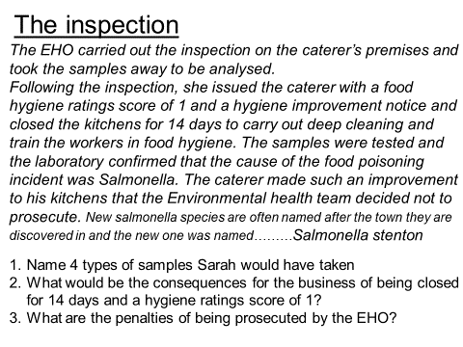
Where am I now?
..................................................................................................................................................................................................................................................................................................................................................................
..................................................................................................................................................................................................................................................................................................................................................................

