Year 10 School Closure Work

Please log on to
www.languagesonline.org.uk

Click on ‘le français’ and pick the unit of work that you need to revise, recall or revisit in relation to your next step or your classwork
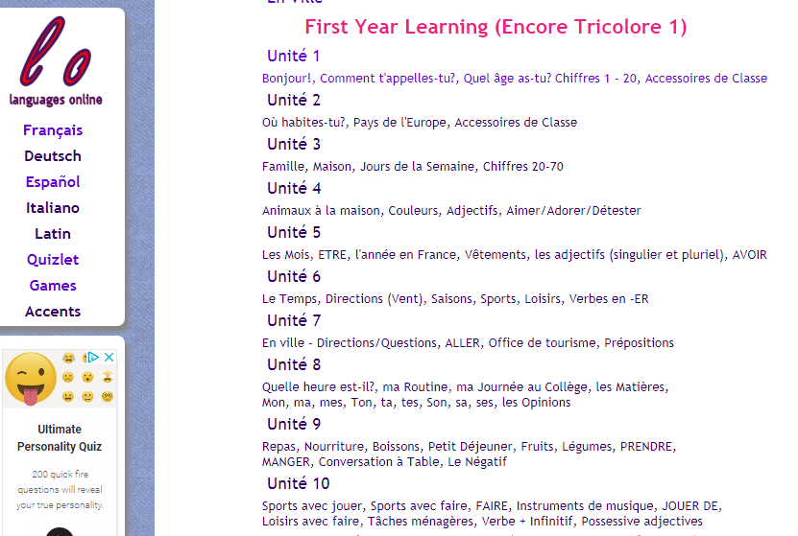

You also have numerous grammar activities you could work through

Following this website you can log on to Kerboodle and continue with your GCSE work. Please work through the Unit we are currently learning in class.
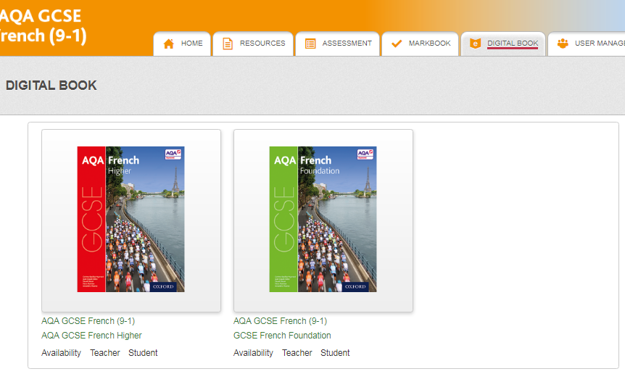

If you do not have access to the internet then I would like you to attempt to write a 90/150 word paragraph on the topics we have studied since Theme 1 trying to include 3 time frames. Remember to use a variety of vocabulary.

You also have your AQA booklets with vocab in to learn. Please go through Theme 1 and 2 and embed key language ready for our return to school.

Merci!!

