Year 10 School Closure Work – Health and Social Care
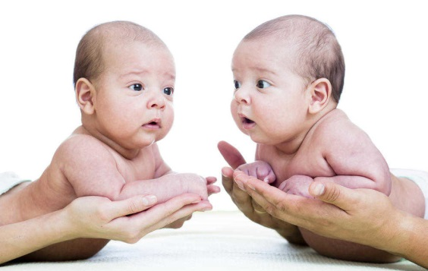
Paula is a new mum of twins, Suzy and James. She hasn’t had children before and is really anxious about how to look after them and what to expect in the first couple of years of their life.

TASK
Write some advice for Paula explaining the development areas Suzy and James are likely to go through up to their 2nd birthday. Include all 4 areas of PIES development. Minimum 500 words.
Email completed work to jocoleman@westleigh.wigan.sch.uk

Expected PHYSICAL DEVELOPMENT of Suzy and James

Expected INTELLECTUAL DEVELOPMENT of Suzy and James

Expected EMOTIONAL DEVELOPMENT of Suzy and James

Expected SOCIAL DEVELOPMENT of Suzy and James

