**History GCSE Unit 1:**

The Plains Indians

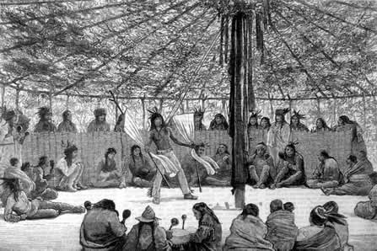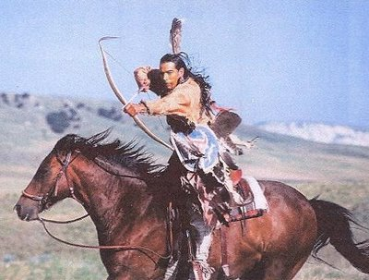



|  |  |
| --- | --- |
| *Key Issue* | *Tick once completed* |
| The geography of North America and the nature of the Plains |  |
| The coming of the Plains Indians; the different tribes: their movement and settlement |  |
| The beliefs and way of life of the Plains Indians – both men and women. |  |

**The geography of North America and the nature of the Plains**

**Geography of the Great Plains**

The Plains can be found roughly in the centre of America.

It is a dry terrain which makes farming extremely very difficult.

The weather on the Plains is extremely warm, with a severe lack of water.

On either side on the Plains are frontiers – a divide or border. These can either be man-made or natural.

The eastern side of the Plains was bordered with the Appalachian Mountains and the Mississippi River; to the Western side are the Rocky Mountains.

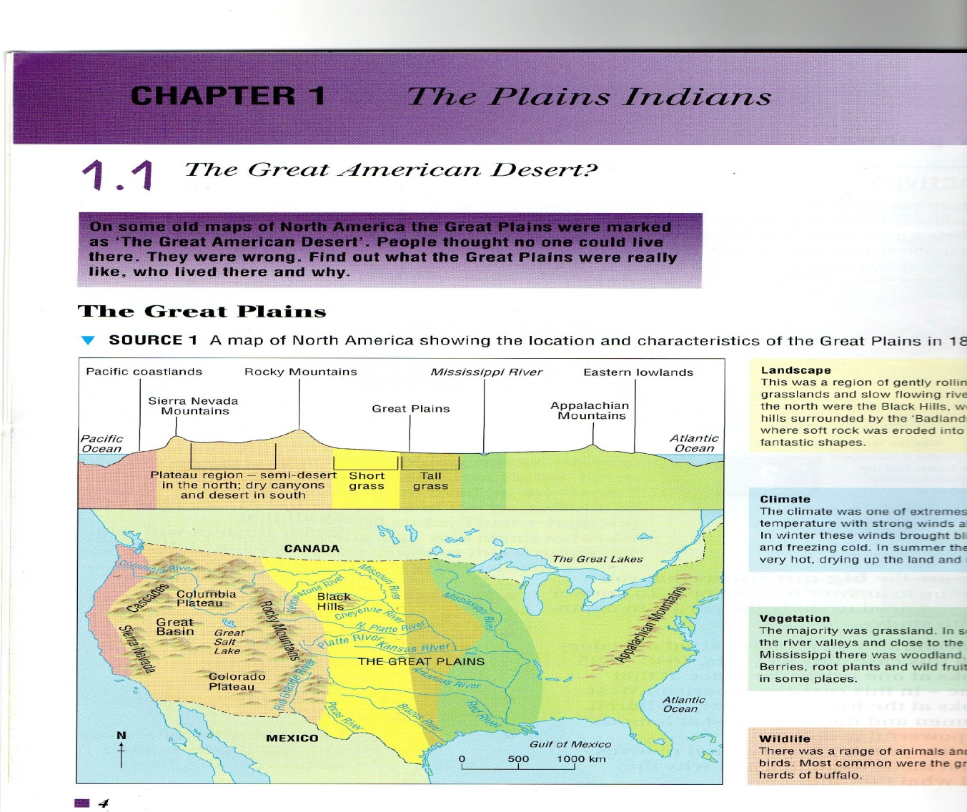

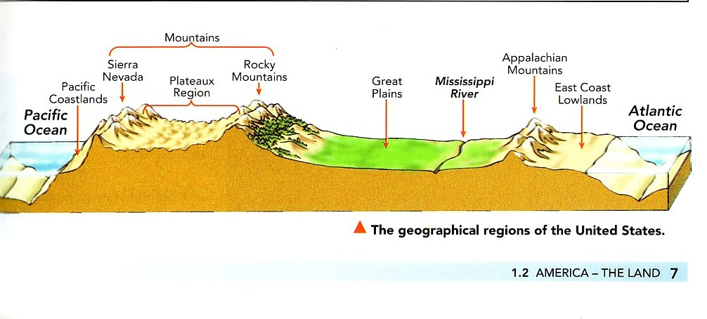

**Other Important Information……**

Date _________________________________

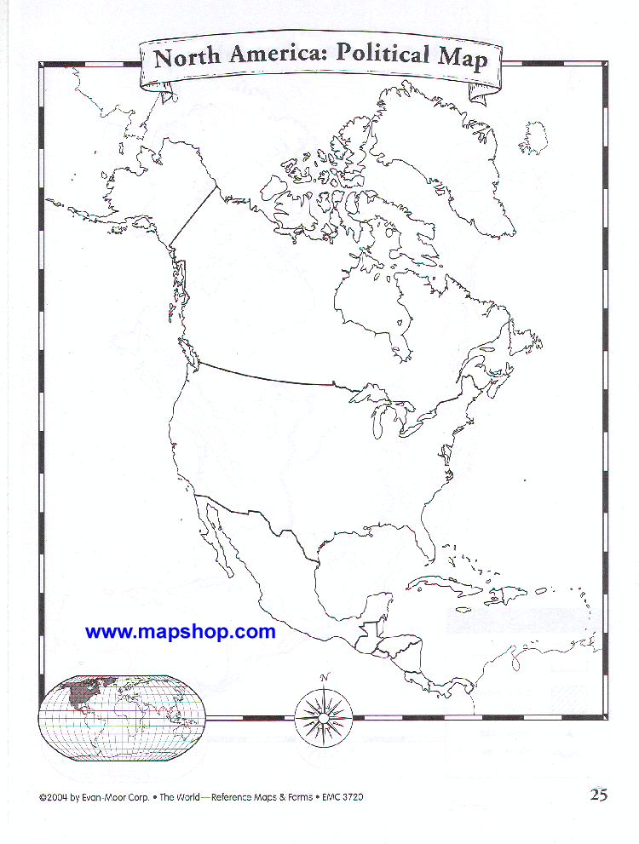

**On the map of the USA, shade where you would find the Great Plains.**

Description of the Great Plains

**Key words to remember/learn:**

|  |  |
| --- | --- |
| **Landscape** | **Wildlife** |
| **Climate** | **Vegetation** |

**Inhabitants of the Plains:**

Living on the Plains were **the Plains Indians**, these were originally from Siberia and had migrated over a period of 500-600 years. Due to the conditions on the Plains, the Plains Indians were a **nomadic** group – they moved around for survival (usually 3-4 times a year – BUT NOT IN THE WINTER MONTHS)

The Plains Indians were hunters as they could not farm the land.

Horses had been taken by the Plains Indians from the Spanish and they had a great impact on the Plains Indians lifestyle

**Other Important Information……**

Date _________________________________

**Names of Different Tribes:**

**Key words to remember/learn:**

**A brief Summary of important information**

**Native American religion - the spirits**

Although early European settlers in America decided that Native Americans had no religion, the opposite was true. In fact Native Americans were **very religious**.

Whenever the hunter came across a beautiful scene ... he paused for a moment in worship.

***Native American belief***

Although many Native Americans believed in a great spirit - called **Wakan Tanka** - their religion was [***animistic***](http://www.bbc.co.uk/schools/gcsebitesize/history/shp/americanwest/religionrev1.shtml). It was based on the desire to **appease 'the spirits'**, which they did in a variety of ways.

* When a young man came of age, he would take part in a ceremony which involved fasting, self-harm, going into a trance and seeing an animal that was a **spirit friend**.
* One of these ceremonies - the **Sun Dance** - featured a structure with a central pole signifying the sun, from which the young men hung themselves by their nipples.
* Native Americans believed that spirits caused the harsh weather of the Plains, as well as illness. They thought that '**medicine men**' could speak to these spirits, and ask for their help.
* They performed the **Mandan Buffalo Dance**, which they thought would bring buffalo to them.



Native Americans were true **lovers of nature**. They believed that humankind ought to live in a way to fit in with nature.

They especially loved the land, which they called their 'mother'

**Other Important Information……**

Date _________________________________

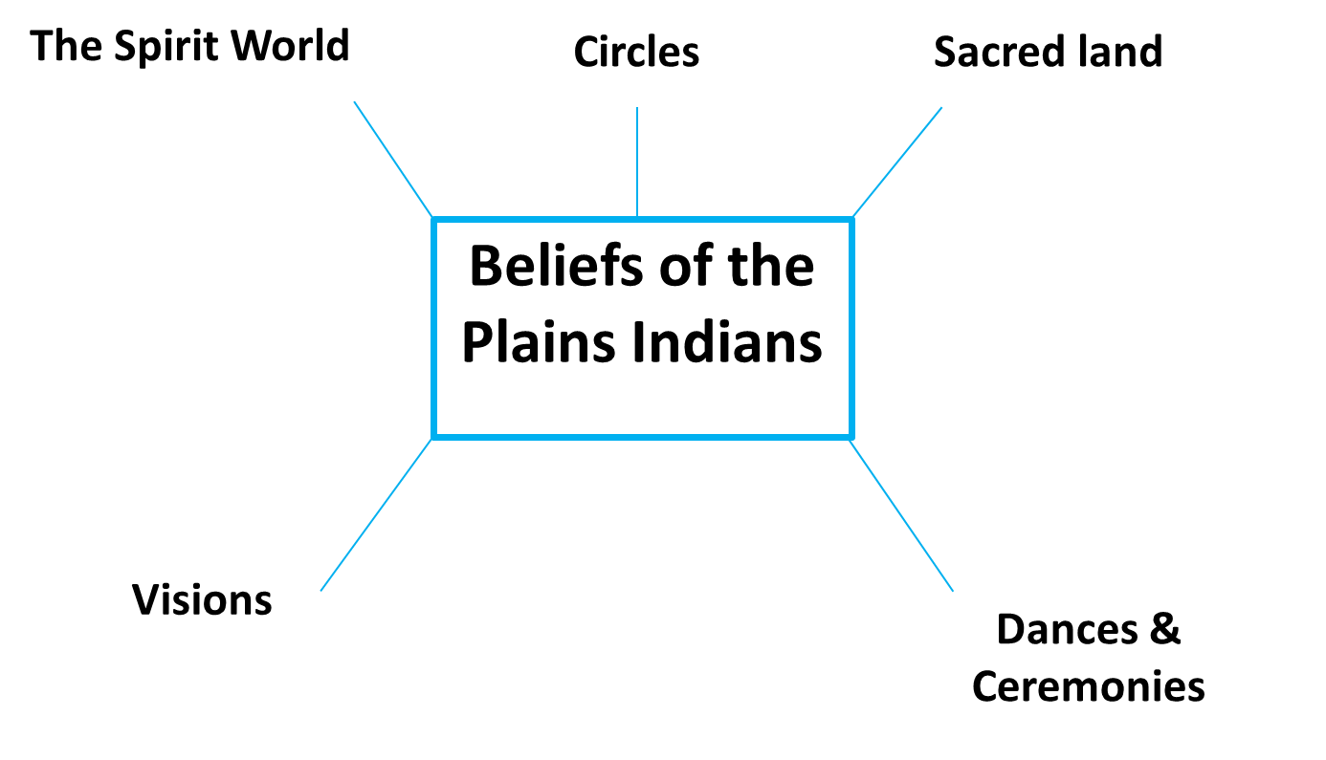

Native Americans thought that:

1. Land was put here by the Great Spirit to **support** mankind.
2. Land did not and **could not belong** to any one person.
3. Land belonged to **all** the creatures.
4. Land could **not be sold**.
5. Land should be **venerated** because the ancestors were buried there.
6. Land was **beautiful** and should be enjoyed by all.
7. Land was eternal and **imperishable**.
8. **Spirits** lived in the earth and it was unwise to anger them.
9. The buffalo needed open land to migrate; fences and **farms were impossible**.

Circles were also extremely important to the Plains Indians as they believed they represented life and re-birth. Circles were incorporated into as many possible areas of life as possible.

**Why were horses important to the Plains Indians?**

* Transport – helped the nomadic people transport

goods and families across vast areas of land

* Warfare – allowed warriors to fight over greater

distances.

* Hunting – vital in hunting for the buffalo
* Horses became a measure or wealth and prestige



**A brief Summary of important information**

**Other Important Information……**

Date _________________________________

**_____________________________________________________________________________________________________________________________________________________________________________________________________________________________________________________________________________________________________________________________________________________________________**

**_____________________________________________________________________________________________________________________________________________________________________________________________________________________________________________________________________________________________________________________________________________________________________**

**Key words to remember/learn:**

**A brief Summary of important information**

**Native American feeling for the la**

**The Buffalo**

The Buffalo was vital for the survival of the Plains Indians. Men would go out to hunt the buffalo (the way of hunting changed with the introduction of the horses onto the Great Plains). The number of buffalo killed was dependent on need – they never killed for fun. Every part of the buffalo was utilised – the heart would be left on the ground as a symbol of re-birth and life.

[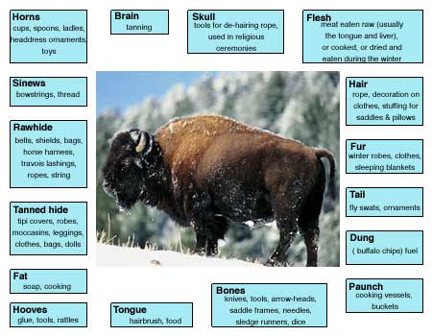](http://www.google.co.uk/url?sa=i&rct=j&q=uses+of+the+buffalo&source=images&cd=&cad=rja&docid=__fCfm-j8QSiLM&tbnid=fc9-EIVSISqmpM:&ved=0CAUQjRw&url=http://www.jeron.je/anglia/learn/sec/history/america/bison.htm&ei=HVtuUdzyFObE0QW41IGYDQ&bvm=bv.45368065,d.d2k&psig=AFQjCNGCCPGENBEs5_0WAyfs1pKfDsPasw&ust=1366273172178552)

**Other Important Information……**

Date _________________________________

**Description of a buffalo hunt:**

**Before Horses**

**_____________________________________________________________________________________________________________________________________________________________________________________________________________________________________________________________________________________________________________________________________________________________________________________________________________________**

**Hunting Buffalo with horses**

**___________________________________________________________________________________________________________________________________________________________________________________________________________________________________________________________________________________________________________________________________________________________________________________________________________________**

**Preparation before a Buffalo hunt**

**During the hunt:**

**How were the Plains Indians organised?**

Lots of different nations of Plains Indians) eg the Sioux Nations

Made up of many tribes *eg Ogala and Hunkpapa*

Each tribe is led by a **Chief of Tribes**

Tribes are broken into many **bands** (made of 10-50 families) who is led by a chief

War society advise chief

Council of men advise chief

**Other Important Information……**

Date _________________________________

**___________________________________________________________________________________________________________________________________________________________________________________________________________________________________________________________________________________________________________________________**

**___________________________________________________________________________________________________________________________________________________________________________________________________________________________________________________________________________________________________________________________**

**Key words to remember/learn:**

**A brief Summary of important information**

**Roles within a family**

|  |  |
| --- | --- |
| Men | The men would hunt for buffalo and take part in the protection of the family and tribe. |
| Women | Women would be responsible for the tipi; the cooking, cleaning and well-being of the family. |
| Children | Boys would be taught hunting and warrior skills, whilst female’s would be taught how to cook etc. Children were very important as they were the future of the tribe. |
| Elderly | The elderly were respected and used for advice – over if they were too frail to move with the tribe, they would be left behind. |

**Other Important Information……**

Date _________________________________

**Marriage**

**___________________________________________________________________________________________________________________________________________________________________________________________________________________________________________________________________________________________________________________________**

**Polygamy**

**___________________________________________________________________________________________________________________________________________________________________________________________________________________________________________________________________________________________________________________________**

**_____________________________________________**

**Key words to remember/learn:**

**A brief Summary of important information**

**The Tipi**



* Each Indian family lived in a tipi
* It was made by buffalo skins sewn together
* It could be easily packed up and moved around
* It was built using readily available resources
* It was the responsibility of the women

**Other Important Information……**

Date _________________________________

**How did the Tipis fit into the Plains Indians lifestyle?**

|  |  |
| --- | --- |
| Description of Tipi feature | Explanation of how it fits into the Plains Indians lifestyle. |
|  |  |
|  |  |
|  |  |
|  |  |
|  |  |
|  |  |

**Key words to remember/learn:**

**Law & Order**

The Native Americans were not one people, but many **tribes**.

The most famous tribes were the:

* Apache,
* Sioux,
* Blackfeet
* Cheyenne

Each one led by its own **Council of Elders**.

The Native American way of government led new settlers on the Great Plains to think that the earliest inhabitants of the land had no government at all. This was not true, but their government was based on principles that the newcomers had difficulty in understanding.

For example, a Native American chief had **no power** over his people, although he did have great **respect** from them, based on his bravery in war. And the only 'police' in Native American society were warriors called **dog-soldiers**, who selected and broke camp, fed the old and the weak, stopped buffalo being scared away, and controlled the hunt.

In fact, the hunt was the only occasion when everybody had to obey. The Native American tribes did not need strict laws, because the harsh environment forced them to work together. Consequently, most tribes had **few laws**, and the worst punishment was banishment (which meant death, given the harsh Plains environment). The only duty that members of the tribe had was to pray.

Because there was a need to take care of the women and children of the tribe, **marriage was easy**. At 17 a youth paid a dowry of horses and took his bride (aged 12-15). The Native Americans practiced polygamy (they had more than one wife), because many men died in the struggle to survive, so there was an excess of women to be cared for.

**Other Important Information……**

Date _________________________________

**A brief Summary of important information about Chiefs**

**The Role of Warrior Societies**

**Key words to remember/learn:**

**Native American view of war**

1. War was based on **ambush** and skill (eg stealing a tied horse).
2. No one was forced to go to war - individual warriors **chose** to follow the chief to war or not, as they felt best.
3. The aim of war was to **capture horses** and to show bravery.
4. The bravest act of war was to score a [***coup***](http://www.bbc.co.uk/schools/gcsebitesize/history/shp/americanwest/nativeamericansrev3.shtml) (where a warrior tapped his enemy with a stick and escaped).
5. Native Americans scalped their enemy to stop him going to an afterworld they called the **Happy Hunting Ground**.
6. The main aim in war was to stay alive, in order to care for the family (**community spirit**).

**Other Important Information……**

Date _________________________________

**Why did Individual warriors fight?**

**______________________________________________________________________________________________________________________________________________________________________________________________________________________________________________________________________________**

**Why did the Plains Indians take scalp?**

**_________________________________________________________________________________________________________________________________________________________________________________________________________________________________**

**Why was counting coup brave?**

**_____________________________________________________________________________________________________________________________________________________________________________________________________________________________**

**Key words to remember/learn:**

**A brief Summary of important information**

**The Medicine Man**

‘Shaman’ is the Plains Indians name, Medicine men was given by whites because he carried herbs.

**Charms**

**C**harms were very important to the Plains Indians.

When a child was born, its umbilical cord was dried and saved. It was decorated and shaped like a turtle for a girl or lizard/rattle snake for a boy.

It was presented to the child when they were older.

They believed the umbilical cord gave them life and would protect them when they were older.

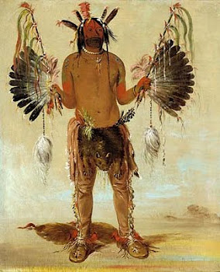

The Plains Indians believed the medicine men could cure the sick as he could use the power of the spirits.

The medicine men could drive away the evil spirit which was causing illness.

Medicine men also used practical remedies, such as ointments and potions to treat the sick. They used herbs

Medicine men were also consulted about every aspect of tribal life – from when to go to war to the buffalo hunt.

**Other Important Information……**

Date _________________________________

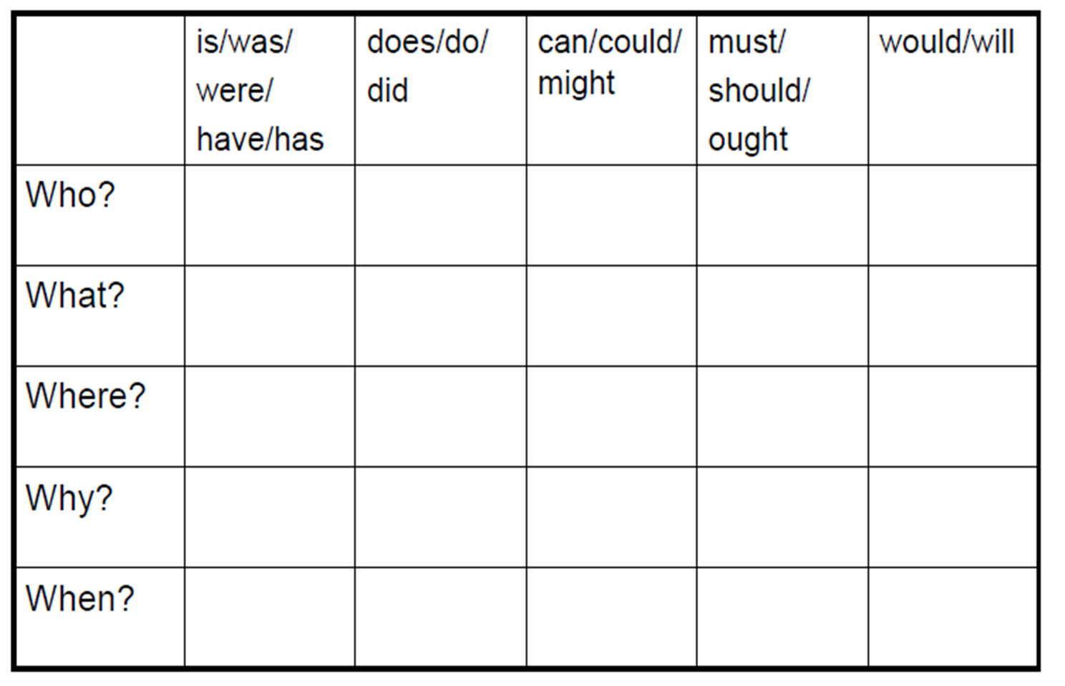

**Why were the Plains Indians so well suited to living on the Great Plains?**

Use the space below to produce a mind map.