How Do I Pick The Career That's Right For Me?

Choosing a career can be a daunting prospect. If you aren't sure what career is right for you, you're not alone – many people your age (and some much older!) are not sure either, and with advances in technology, new areas of work are opening up as quickly while some traditional fields of work are being phased out. If you are sure about the career you want to follow, you still need to make sure you're taking the right steps towards your goal. So, whether you're already set on your future career, or in need of a few ideas, here are some things to think about.

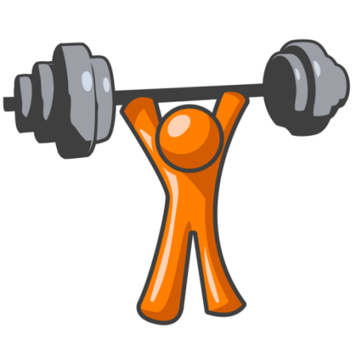
- Your Strengths

Everybody has things that they're good at and things that they're not so good at. Make a list of your strong points – the things you feel you excel in. Think about what you feel confident in doing; what you've been told you do well; what you're passionate about; activities you like to do when you're not doing schoolwork; what you think you're better at than a lot of people. All of these are clues to what your strengths are. Make a list of skills that you have. If you're having trouble thinking of any skills or strengths, ask a family member, friend, or teacher who knows you.

You can then use this list of strengths and skills to focus on the types of work that you might find enjoyable. For example, if your best subject is Maths and you're strongly interested in finance and the economy, it makes sense to develop those interests and skills by following a career related to Economics or Finance. It's a good idea to play to your strengths – in other words, taking advantage of the skills and interests that you've already got. This doesn't mean you can't learn new skills and develop new interests – quite the opposite! By paying attention to what you're already interested in, you can choose the kind of career that will develop your skills and abilities to help you meet your full potential.

If you have already chosen your career, you may need to make sure that you have the strengths required for the job. You may also need to acquire some of the strengths that you need. For example, if you want to be a doctor, not only are you going to need good academic results, you'll also need to not faint at the sight of blood, be calm under pressure, and be able to communicate with a wide range of people of all ages, backgrounds, beliefs and so on. Find out about the skills needed for your chosen career, and do things that will help you to acquire those skills.

- What You Want

People have different motivations for going into their careers. Some people are primarily motivated by money, and their priority is getting a job that is extremely well-paid. Some people are primarily motivated by the desire to help people, and their priority is having a job that will allow them to improve people's lives. Other motivations might include: having a job that you find interesting; working outdoors (or indoors); having a job that doesn't take over your life; doing a job that allows you to innovate and create new technologies, ideas or methods; having a job that involves communicating with lots of people (or very few people); doing a job that is regarded as prestigious; working in a sector that is beneficial for the environment; having a job that is secure; having a job that is 'hands on' (i.e. involves doing things with your hands and doesn't involve staring at a screen all day); having a job that is intellectually challenging, being a leader, and so on. There are so many different things that motivate people, and of course, most people are motivated by a combination of these things and more. You need to think carefully about what your own priorities are. If, like most people, you find that you have several important motivations, you need to decide whether they are all equal or if one might be slightly more important than the others.

- Your experience
Doing some work experience is essential. This is because you never know what a career is like until you are doing it. Work experience is a way of trying a career before committing to it. Of course, as a work experience student, you are unlikely to get to do any of the really interesting or exciting parts of the job, but this is important preparation for the world of work: it often takes years of working in junior positions before you can progress to the level that you ideally want to be working at. Doing work experience will give you a flavour of what to expect in your chosen career, which is important as it might be different from your expectations.
Work experience is also important from the point of view of employers, universities and other important institutions. This is because it shows that you are serious about working in your chosen area, as well as showing that you're a motivated person who takes initiative, shows skills of organisation, communication and teamwork.
- Take a test
You can take several tests to help you when deciding on your future. As well as the Myers-Briggs test mentioned above, there are a number of free careers tests available online. You can also consult your school's resources, such as the Careers section of the Library, or the or the school's Careers Advisors, who may be able to provide you with more information.

