KS3 Acid scientist
Definitions |  |  | Neutralisation reactions- naming salts
1 | Acid | All acids contain Hydrogen. An acid is the opposite to a base. E.g Hydrochloric acid | 16 | Hydrochloric acid | Make a chloride salt
2 | Alkali | A base that can dissolve in water is also called an alkali. | 17 | Sulphuric acid | Make a sulphate salt
3 | Base | A base is the opposite to an acid. | 18 | Nitric acid | Make a nitrate salt.
4 | Indicator | A substance used to detect whether something is an acid, base, or neutral. | Investigation skills- safety
5 | pH | The pH of a substance tells us if something is an acid or alkali. | 19 | Goggles | Need to be worn to protect the eyes from chemicals and anything that might injure the eyes.
6 | pH scale | The pH runs from 0 (strongly acidic) through 7 (neutral) to 14 (strongly alkaline). See diagram 1. | 20 | Heat proof mat | Used when anything flammable is used.
7 | Neutral | A substance that is neither acid or base. It has a pH of 7. | 21 | Slips, trips and spills | All objects must be stored safely. Spillages and breakages must be reported immediately.
8 | Neutralisation | Neutralisation involves an acid reacting with a base or an alkali, forming a salt and water. | 22 | Fire hazards | Fire blankets, extinguishers, sand buckets are used to control any accidents.
9 | Hazard | Something that could potentially cause harm. | 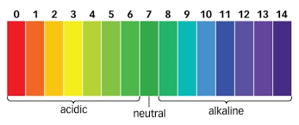 |  |  | 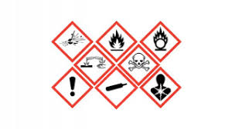
10 | Irritant | Something that could cause an irritation e.g itching, difficulty breathing.
11 | Corrosive | A substance that has the power to cause irreversible damage or destroy another substance by contact.
12 | Flammable | Something that could set on fire easily and burn quickly.
13 | Oxidising | This substance gives a large amount of heat when in contact with another substance.
14 | Litmus paper | Blue litmus paper turns red under acidic conditions and red litmus paper turns blue under basic or alkaline conditions.
15 | Universal indicator | A mixture of dyes that changes colour gradually over a range of pH. | Diagram 1: pH scale |  |  | Diagram 2: Hazard symbols

