Title – Evolution Scientist
Definitions
1 | Species | A group of organisms that can breed among themselves to produce fertile offspring. | 16 | Invertebrate | An organism without a backbone.
2 | Variation | Differences between individuals in a species. | 17 | Adaptations | Special features that make an organism well suited to its environment.
3 | Continuous data | Data that can take any value. | 18 | Competition | Organisms compete for limited resources such as food, light, mates.
4 | Discontinuous data | Data that has a particular value. There are no in-betweens. Eg. eye colour. | Key steps of natural selection
5 | Environmental variation | Differences in characteristics caused by the environment/lifestyle. |  | 1 | Mutation (change) of a gene.
6 | Genetic variation | Differences caused by genes inherited from parents. |  | 2 | Mutation gives the organism an advantage and so survives.
7 | Genome | All the genetic material of an organism. |  | 3 | Organisms breed.
8 | Fossil | The preserved impression/remains of an animal or plant whose living tissue has been replaced by minerals |  | 4 | Mutated gene passed on to offspring.
9 | Fossilisation | Process of organisms becoming fossils. | 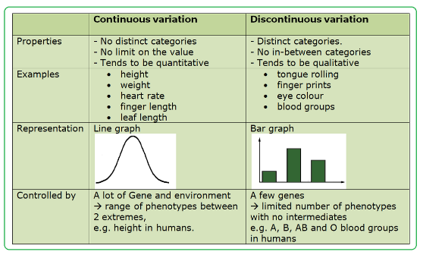 |  |  | 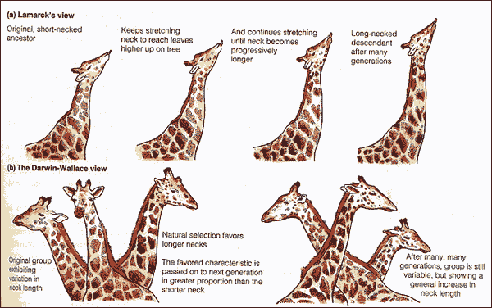
10 | Fossil record | Set of fossilised remains that tells how organisms have changed over time.
11 | Classify | Arrange in groups according to characteristics.
12 | Classification | Process of classifying organisms.
13 | Key | Series of questions to classify an organism.
14 | Vertebrate | An organism with a backbone.
15 | Evolve | Development of organisms over time. | Continuous and discontinuous data |  |  | Two theories of evolution.

