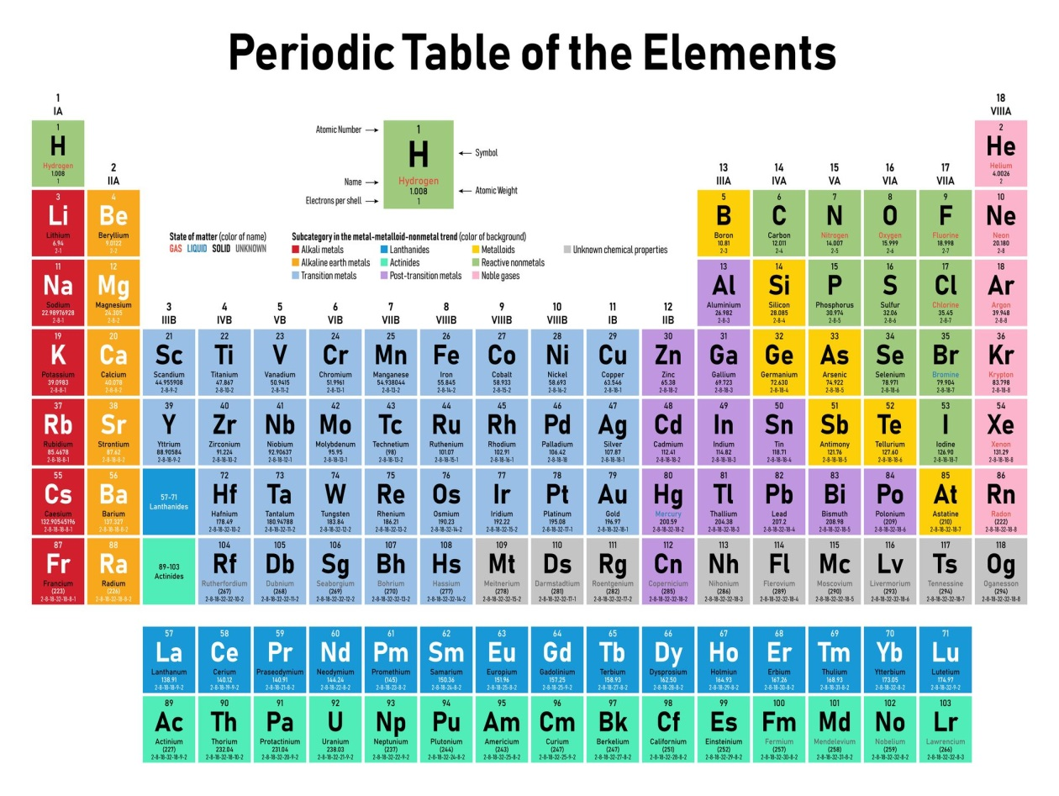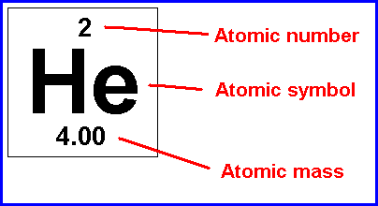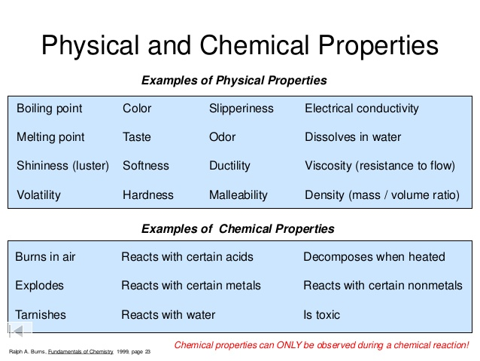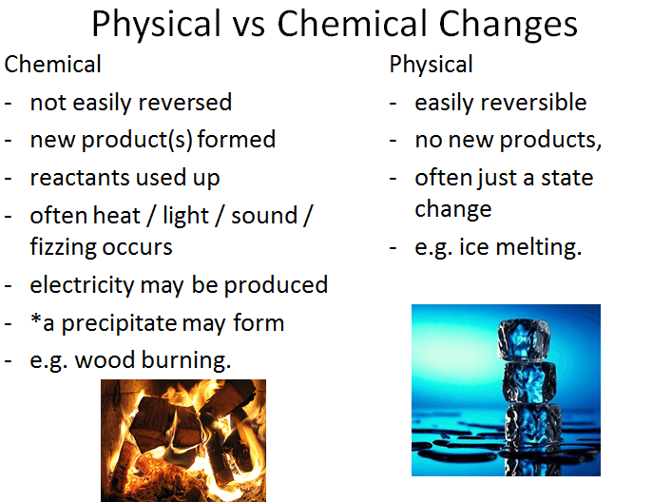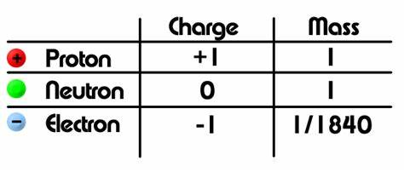[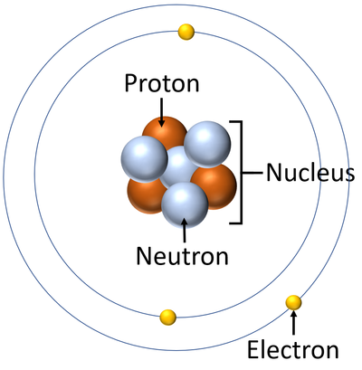](https://www.google.com/url?sa=i&url=https://keystagewiki.com/index.php/Atom&psig=AOvVaw3mm_2e792SSAh1KBP4Y1jM&ust=1585217291710000&source=images&cd=vfe&ved=0CAIQjRxqFwoTCLDfkuOwtegCFQAAAAAdAAAAABAE)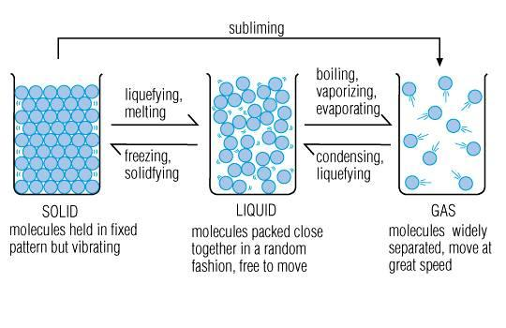

***Melting point:*** *the temperature that a substance changes from a solid to a liquid.*

***Boiling point:***

*The temperature that a substance changes from a liquid to a gas*

**periodic table scientist**