The ‘Haka’
The Haka is a traditional ancestral war cry, dance or challenge from the Māori people of New Zealand. It is a posture dance performed by a group, with vigorous movements and stamping of the feet with rhythmically shouted accompaniment. The New Zealand rugby team's practice of performing a haka before their matches has made the dance more widely known around the world.
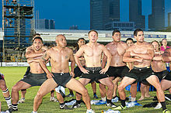

Haka being performed at the SCC Rugby Sevens

History

Haka are performed for various reasons: for amusement, as a hearty welcome to distinguished guests, or to acknowledge great achievements, occasions or funerals.
War haka were originally performed by warriors before a battle, proclaiming their strength and prowess in order to intimidate the opposition. Today, haka constitute an integral part of formal or official welcome ceremonies for distinguished visitors or foreign dignitaries, serving to impart a sense of the importance of the occasion.
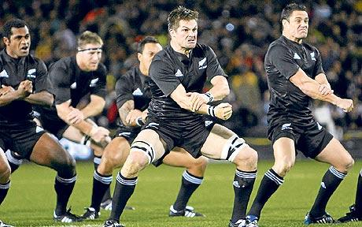
Various actions are employed in the course of a performance, including facial contortions such as showing the whites of the eyes and the poking out of the tongue, and a wide variety of vigorous body actions such as slapping the hands against the body and stamping of the feet. As well as chanted words, a variety of cries and grunts are used. Haka may be understood as a kind of symphony in which the different parts of the body represent many instruments. The hands, arms, legs, feet, voice, eyes, tongue and the body as a whole combine to express courage, annoyance, joy or other feelings relevant to the purpose of the occasion.

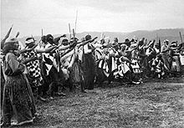
Types

A group of men and women perform a haka for Lord Ranfurly at Ruatoki, Bay of Plenty, in 1904
The various types of haka include whakatu waewae, tutu ngarahu and peruperu. The peruperu is characterised by leaps during which the legs are pressed under the body. In former times, the peruperu was performed before a battle in order to invoke the god of war and to discourage and frighten the enemy. It involved fierce facial expressions and grimaces, poking out of the tongue, eye bulging, grunts and cries, and the waving of weapons. If the haka was not performed in total unison, this was regarded as a bad omen for the battle. The aim of the warriors was to kill all the members of the enemy war party, so that no survivors would remain to undertake revenge.

Gender of participants
Most haka are performed by men, with the female role, if any, limited to providing support by singing in the background.
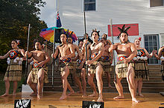

A performance by the Kahurangi Maori Dance group.

Cultural impact
In the lead up to the Rugby World Cup in 2011, flashmob hakas became a popular way of expressing support for the All Blacks.
In November 2012, a Maori kapa haka group from Rotorua performed a version of the 'Gangnam Style' dance mixed with a traditional Maori haka in Seoul, celebrating 50 years of diplomatic relations between South Korea and New Zealand.

Creative Task
Research further on ‘Haka’ dance. View some clips on youtube. Have a go at creating a short piece of dance, incorporating the style of the ‘Haka’. If you are able to do so, film your performance. Evaluate: WWW & EBI….what did you do well? What have you learnt? What could you improve?

