TASK 1
Go to the website:
http://www.bagill.com/text-converter.php
Convert your name into binary.

Run-length encoding is a simple computer method of LOSSLESS compressing or encoding data.
When there is a pair or more than TWO bits the same (a ‘run length’ of common digits), we can compress those bits by writing how many - length - of those common bits (run) there are.

For example:
11000010 114010 - this means there is a string of four zeroes in the sequence
Data | Number of bits
11000010 | 8 bits
214010 | 6 bits (‘compressed’)

EXAMPLE
MY NAME (ASCII characters) | JOHN SMITH | HOW MANY DIGITS?
MY NAME (in BINARY - uncompressed) | 0100101001101111011010000110111000  1000000101001101101101011010010111  010001101000 | 80 digits
MY NAME (in BINARY – compressed) | 0120101202104102101402103130  16010120210210210102101201031  0130210130 | 67 digits  = 17% compression

* COUNTING BITS IN THE ‘UNCOMPRESSED’ NAME EACH LETTER = 1 BYTE = 8 BITS

Using the website:
http://www.bagill.com/text-converter.php

- fill in the table below with:
- your name
- your name in BINARY
- your name ‘compressed’ using RUN-LENGTH ENCODING
- how many digits storage space your name takes UNCOMPRESSED
- how many digits storage space your name takes COMPRESSED
- the compression %age
MY NAME (ASCII characters) |  | HOW MANY DIGITS?
MY NAME (in BINARY - uncompressed) |  | ___ digits
MY NAME (in BINARY – compressed) |  | ___ digits  = ___ % compression

* COUNTING BITS IN THE ‘UNCOMPRESSED’ NAME EACH LETTER = 1 BYTE = 8 BITS

TASK 2
Write down the run length encoding for the following images. 0 means white and 1 means black.
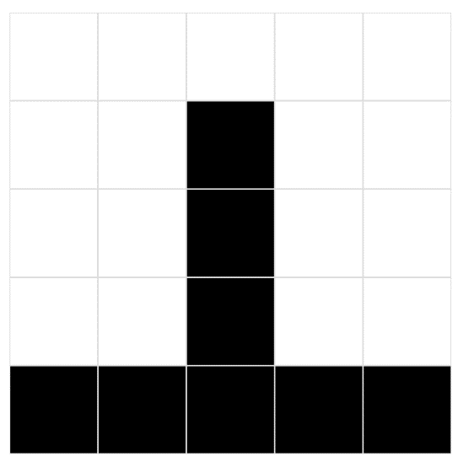
Original num of bits | Original bits | Compressed characters | Compressed num of characters

Original num of bits | Original bits | Compressed characters | Compressed num of characters
Original num of bits | Original bits | Compressed characters | Compressed num of characters
Original num of bits | Original bits | Compressed characters | Compressed num of characters

Original num of bits | Original bits | Compressed characters | Compressed num of characters

