KS3 Particle model
Definitions
1 | Solid | Particles have a fixed volume and fixed arrangement. | 16 | Mixture | Two or more elements that are not chemically bonded together.
2 | Liquid | Particles have a fixed volume but no fixed arrangement. | 17 | Boiling Point | The temperature at which a liquid changes into a gas.  NOTE: Condensation point is the same temperature.
3 | Gas | Particles have no fixed shape or volume. Fill the container they are in and can be condensed. | 18 | Melting point | The temperature at which a solid changes into a liquid.  NOTE: Freezing point is the same temperature.
4 | Evaporation | The process by which a liquid turns to a gas. | Properties of solids, liquids and gases
5 | Condensation | The process by which a gas turns to a liquid.
9 | Change of state | The changing of one state to another. | 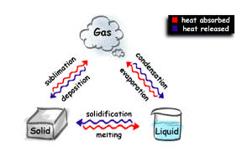 |  |  | 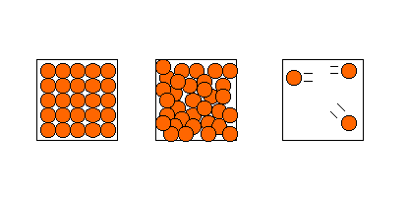  Solid Liquid Gas
10 | States of matter | A solid, liquid or gas.
11 | Physical change | Involves a change in the state of matter. No new compound is made and it can be reversed.
12 | Chemical change | Involves a change in the chemical composition. New compounds are made.
13 | Atom | Everything in the universe is made up of atoms.
14 | Element | Every element is made up of its own type of atom
15 | Compound | Two or more different elements that are chemically bonded together. | Diagram 1: Change of state |  |  | Diagram 2: States of matter

Definitions |  |  | Common Formulae of gases
1 | Solution | A mixture of a solid dissolved in a liquid. |  | O₂ | Oxygen
2 | Solvent | A liquid in which a solid dissolves. |  | N₂ | Nitrogen
3 | Solute | A solid that dissolves in a solvent to form a solution. |  | H₂ | Hydrogen
4 | Saturated | When no more solute will dissolve. | Common Formulae of compounds
5 | Dissolve | To become part of a liquid. |  | H₂O | Water
6 | Suspension | A mixture where insoluble particles are distributed throughout the liquid. |  | CO₂ | Carbon dioxide
7 | Soluble | Can be dissolved. |  | NH₃ | Ammonia
8 | Insoluble | Cannot be dissolved. |  | CH₄ | Methane
9 | Filter | Removes undissolved chemicals from a solution. | 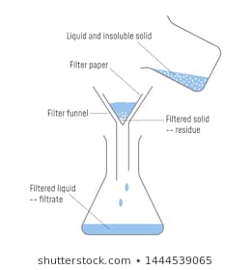 |  |  | 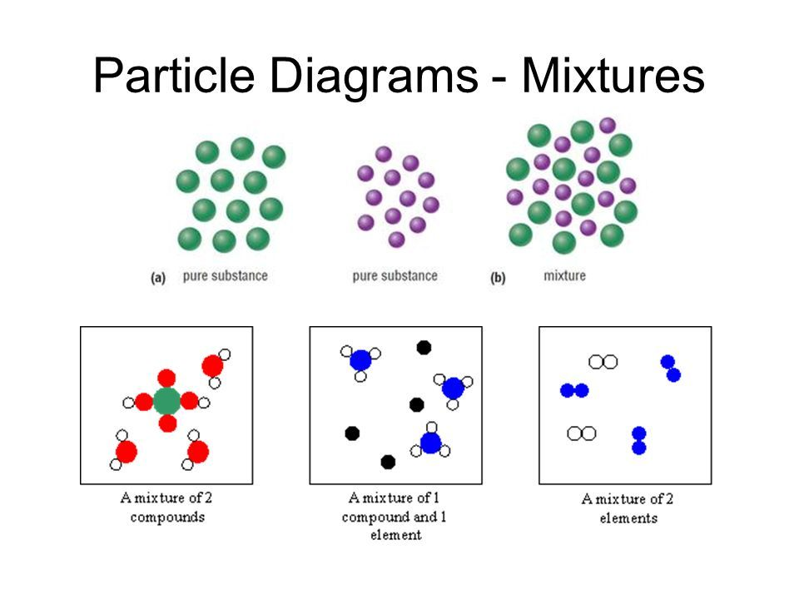
10 | Filtrate | The solution that passes through the filter paper.
11 | Residue | The solid left behind on the filter paper.
12 | Symbol | Single letter or 2 letters representing an element.
13 | Formula | Combined symbols showing the different elements in a chemical.
14
15 |  |  | Diagram 1: Filtration apparatus |  |  | Diagram 2: Mixtures of compounds and elements

